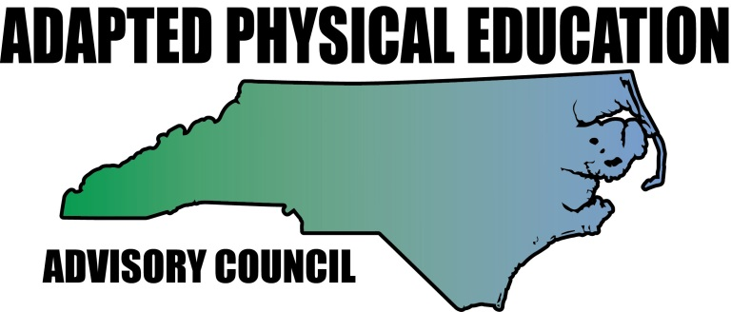www.nc-ape.com
Ann Hughes, CAPE, NBCT
Wilmington NC
Team Half-Marathon is a great warm-up activity for students with and without disabilities.
Discuss with students what a half-marathon is and how far one must run/walk to complete (13.1 miles – incorporate math skills too).
Equipment:
- 4 tall cones.
- Laminated Team-Half Marathon mile sheet(s) Can use expo marker to make check marks.
- Equipment for mile skills (soccer ball for each student for this particular activity).
Set-Up:
- Create square using the cones. (Adjust size to fit the distance you would like students to travel during the walk/running miles.
- Display the Half-Marathon mile sheets/directions.
- Depending upon class size can keep all together or divide class into teams that start at different cones. Each cone should have laminated Mile Sheets.
- As a team, students complete 13 skills as a group. Each mile is complete when everyone in group has completed the movement. Upon completion of the 13 skills, students will receive a certificate for going the distance and completing the half-marathon.
ADAPTATIONS:
During different units (basketball, volleyball, soccer, etc.) you can include different sport skills (Dribble basketball in place).
Sighted guide for individuals with visual impairments.
Provide Physical or Partial assistance.
Students who are physically limited (those who use a walker or wheelchair for mobility) can travel shorter distance when walking or running skills are involved. If choose to complete same distance as team, he /she won’t be left behind because team will wait to move onto next mile.

