www.nc-ape.com
Jolanda Hengstman, CAPE, NBCT
Adapted Physical Education Consulting Teacher
Charlotte Mecklenburg Schools, NC
Jolanda.hengstman@cms.k12.nc.us
Put-Put (Golf)
Equipment: Striking implement: golf-club, hockey stick, adapted hockey stick, racket, baseball bat,
floor hockey sticks, tape the stick to a walker or wheel-chair.
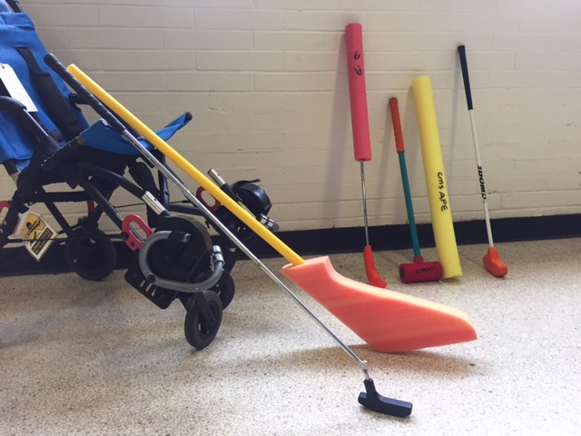
From left to right: club with movable-hinged foot, large foot hockey stick, golf club with enlarged grip using a pool noodle and grip markings, crocket mallet, half a pool noodle, junior golf club
Ball: yarn-ball, large golf ball in a bright color, old tennis ball, variety of colors, sizes and rolling speeds.
Targets: Velcro-targets (homemade or commercially available), boxes on their side, putting-cup made from cardboard, bucket behind an incline mat, hula-hoops.
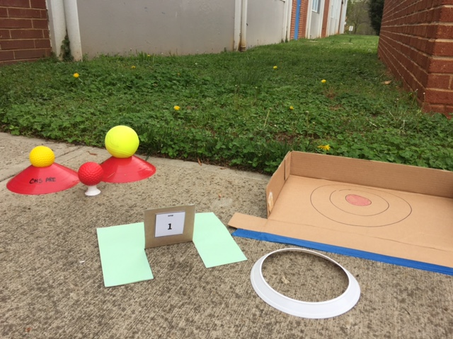
From left to right raised Ts with larger balls, hole #1 made from card board, low ring target, box-lid with one side taped down.
Set-up: Skill practice: All students push/swing/put in the same direction for safety.
Putting course: Use your imagination. Mats, boards, card-board cups, chairs, boxes.
Allow players a designated maximum number of strokes per hole.
Return the ball to the tee before each put.
Involve students: Have students design the putting course.
Ask what a student needs to be successful.
Ask a student what changes might help them be successful.
Provide choices in equipment and course lay-out.

Adaptations: Grip: Enlarge with tape or rubber tubing.
Mark club or tubing with marker for thumb placement.
Functional use of one arm: use either left or right handed club with forearm
swing, or the opposite with backhand swing.
Stance: Mark foot placement with flour or chalk.
Provide support as needed. Chair, crutch, remove arm-rest and/or foot plate.
Swing: Decrease arc of the swing to negate balance issues.
Raise the ball (design a higher of the ground tee).
Target: Shorten the distance.
Make the cup larger.
Make it interesting and fun.

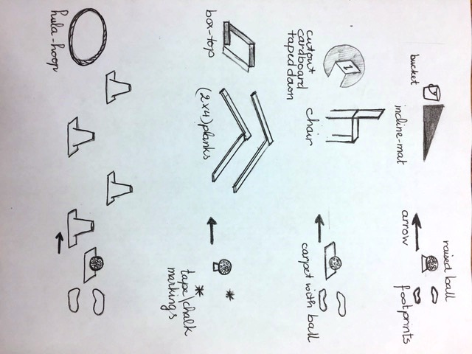

Golf Score Card
Count how many times you had to put the ball before it rolled into the “hole”.

Name: _____________________ Buddy: _______________________
Teacher: ___________________ Teacher: ______________________
- 1 2 3 4 5 1. _____
- 1 2 3 4 5 2. _____
- 1 2 3 4 5 3. _____
- 1 2 3 4 5 4. _____
- 1 2 3 4 5 5. _____
- 1 2 3 4 5 6. _____
- 1 2 3 4 5 7. _____
- 8. _____

If there is time left you can try and improve your score.

Adaptations to the score card: Prewrite name or use a picture.
Instead of counting use a stamp to indicate the student finished the “hole”.
Use tallies.
Cross out the pre-written numbers.

