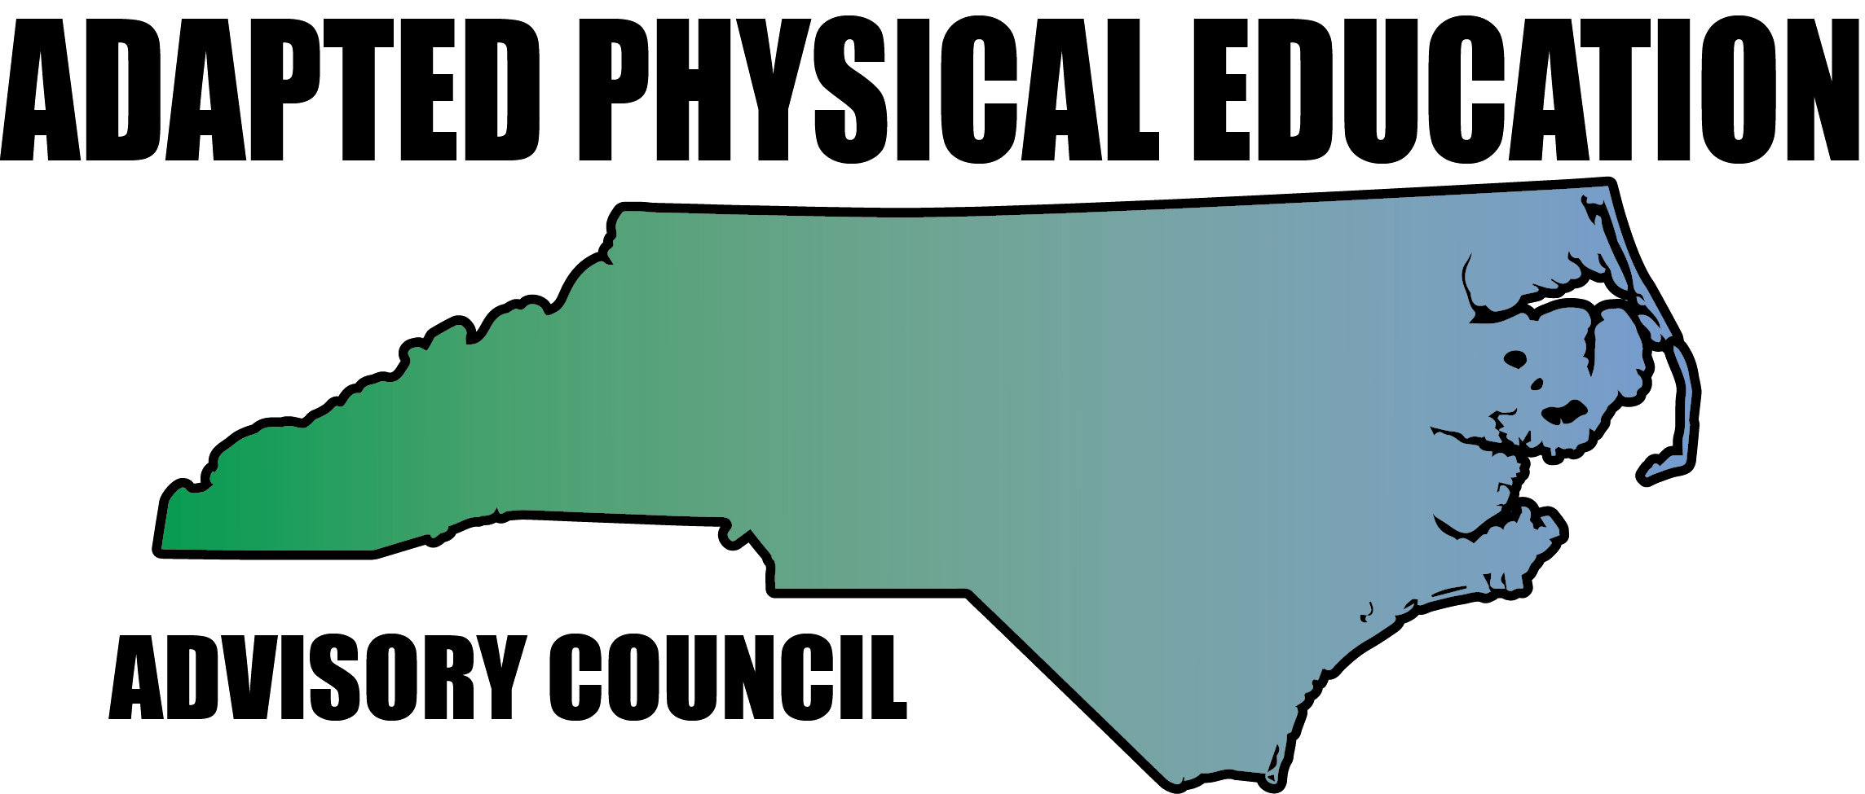

Qualification to Provide Adapted Physical Education

Adapted physical education (APE) is special education (specially designed instruction) in the Healthful Living/Physical Education (PE) curriculum. APE is best provided by an adapted physical education specialist holding certification in APE. However, APE can be provided by any teacher who holds current North Carolina (NC) licensure in physical education. A class cannot be physical education unless the instructor leading it is licensed in PE.

Physical education teachers for general physical education are strongly encouraged to find consultative support from an APE specialist to improve participation by all students, especially those with disability. North Carolina has the NC APE Advisory Council (NC-APE-AC) to assist physical educators to include all students and with all aspects of APE. Regional contacts can be found at the NC DPI APE webpage: http://ec.ncpublicschools.gov/instructional-resources/adapted-physical-education under NC-APE-AC.

The Individuals with Disabilities Education Improvement Act (IDEIA, 2004) states: “The state educational agency has established and maintains qualifications to ensure…that those personnel have the content knowledge and skills to serve students with disabilities” [(Part B-State Eligibility)(612)(14)(A)]

While APE can be provided by any teacher who holds current NC licensure in PE, to ensure adequate content knowledge, each student is educated in his/her least restrictive environment and to elicit full participation of all students; Local Education Agencies (LEAs) are encouraged to hire:
- APE specialist(s) holding certification in Adapted PE.
- NC licensed PE instructor(s) with one of the following:
- Minor in Special Education
- Advanced specialization such as Masters in APE
- National Board Certified Teacher (because a level of reflection and understanding is expected related to knowledge of students, subject area, and differentiated instruction).

In addition the following is highly recommended:
- CAPE (Certified Adapted Physical Educator) certification (www.APENS.org)
- Involvement in sport organizations serving athletes with disabilities such as Special Olympics, Paralympics, Miracle League, etc.
- Teaching experience in PE and APE

Under limited supervision, an adapted physical education specialist or general education PE teacher provides a diversified program of specifically designed activities for students who meet verification criteria for physical, mental, and/or emotional handicapping conditions and are not able to participate safely or successfully in the regular physical education program.
Essential Functions:
- conduct APE evaluations and report results to IEP team;
- develop APE programs at the school level;
- co-teach with general PE staff;
- be a resource to general PE staff and EC staff;
- serve as IEP team member;
- develop IEP components related to APE in collaboration with IEP team;
- coordinate programs with local agencies outside of the school setting;
- provide consultation regarding athletic and recreational opportunities;
- develop and implement in-service training for LEA regarding including all students in PE and APE;
- procure and disseminate appropriate APE equipment;
- maintain knowledge of best practices, current issues and technology;
- maintain adequate records (e.g. class record, IEPs, equipment);
- physical ability to lift, move, carry, pull or push equipment and/or students.

North Carolina Adapted Physical Education Advisory Council (NC-APE-AC)
www.NC-APE.com
NCAPEAC@gmail.com

