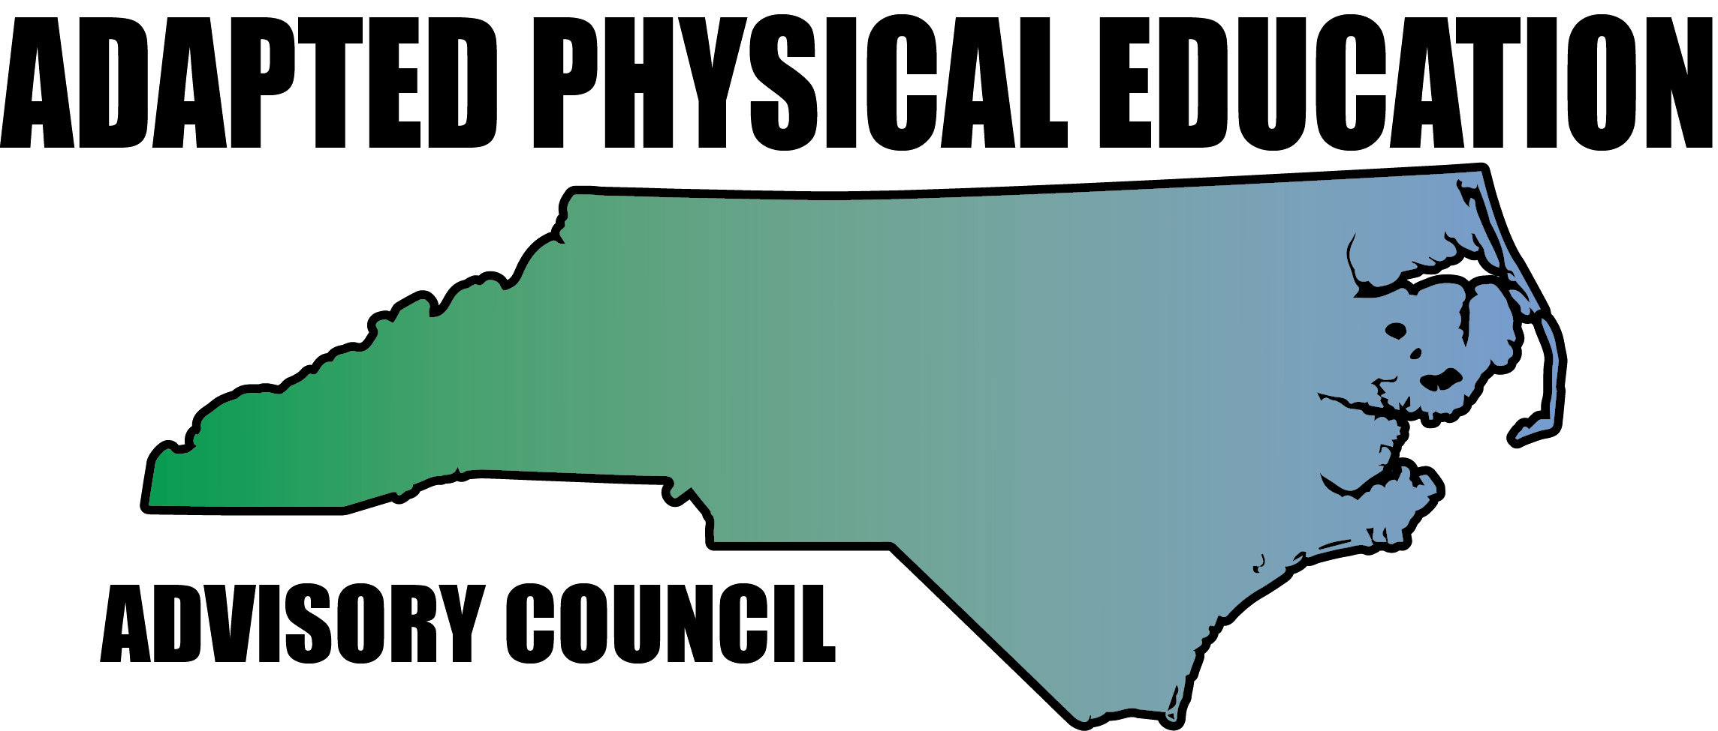

Evaluation and Eligibility for
Special Education in the Area of Adapted Physical Education

Adapted physical education is special education (specially designed instruction) and not a related service. All students should receive at least the same amount of physical education regardless of whether they are receiving general or special education. Just because a student has a disability or is receiving special education does not necessarily mean he/she requires specially designed instruction in physical education or adapted physical education (APE).

Using data from student performance, Individual Education Program (IEP) teams determine if the student needs specially designed instruction (Adapted Physical Education or APE) just as they determine the need for any other specially designed instruction (as in English Language Arts). The only difference is that data is drawn from the student’s ability to learn and make progress through the Healthful Living/Physical Education curriculum. NC Policies Governing Services for Students with Disabilities state (NC 1500-2.1) that:
- Children with disabilities shall have equal access to the provision of physical education. Physical education includes the development of:
- Physical and motor fitness;
- Fundamental motor skills and patterns; and
- Skills in individual and group games, sports, and activities (including intramural and life-time sports).
- If a child with a disability cannot participate in the regular physical education program, individualized instruction in physical education designed to meet the unique needs of the child shall be provided. Physical education may include:
- Modified physical education,
- Adapted/special physical education,
- Movement education, and
- Motor development.
- Modified physical education is appropriate for a child who can participate in the general physical education program with accommodations or modifications. These modifications can include changing rules, equipment, time limits, etc. It can also include supports such as a sign language interpreter.
- Adapted physical education (also called specially designed or special physical education) is instruction in physical education that is designed on an individual basis specifically to meet the needs of a child with a disability.
(Authority: 20 U.S.C. 1401; 34 CFR 300.39(2)(3))

In order to make this determination, IEP teams require information and data about how the student learns and participates in physical education (PE). As NC policy states: evaluation means procedures used to determine whether a student has a disability and the nature and extent of the special education and related services that the student needs. Eligibility of students must be determined by using multiple sources of data and must not be dependent upon single test scores. Evaluation procedures may include, but are not limited to, observations, interviews, behavior checklists, structured interactions, play assessment, adaptive and developmental scales, criterion-referenced and norm referenced instruments, clinical judgment, and tests of basic concepts or other techniques and procedures as deemed appropriate by the professional(s) conducting the evaluations. The determination of needed screenings and evaluations is based upon the unique needs of the student.
(Authority: 20 U.S.C. 1414(a)—(c); 34 CFR 300.15)

Sources of existing data documented at both initial referral and reevaluation include (but are not limited to):
- Observations from PE class
- PE Teacher input
- Formal assessments
- Informal assessments
- Student input
- Parent input

A listing of frequently used assessments can be found on the NC DPI APE webpage: http://ec.ncpublicschools.gov/instructional-resources/adapted-physical-education

Students should be provided the opportunity to participate in the general physical education program before considering a referral for an APE evaluation. Eligibility for APE (as with English Language Arts or any other curricular area) is determined by the IEP Team based on student data and evaluation. These data should provide the IEP team information about student strengths and needs associated with participating in and progressing through NC Healthful Living Essential Standard-Physical Education, (http://www.ncpublicschools.org/docs/acre/standards/new-standards/healthful-living/khs.pdf).

Best practice dictates that an adapted physical education specialist should conduct the evaluation for this area. In the case that the local education agency (LEA) does not have an adapted physical education specialist, the general education physical education teacher collaborates with a special education teacher, occupational therapist and/or physical therapist to provide the IEP team with the student data and information required to determine what is needed for the student to access and fully participate in the PE curriculum.

If the IEP team determines APE is necessary, a specially designed physical education program is developed and provided by general PE teachers (consulting with special education teachers and related service providers as needed) and/or adapted physical educators. The IEP team must discuss and establish student goal(s) in the area of physical education, determine the least restrictive environment for him/her to receive PE, identify required supports and service delivery (frequency and duration), as well as how student progress in this curricular area will be monitored.

It is recommended that an adapted physical education specialist develop student goals in this area. If an adapted physical education specialist is not available, the general education physical educator should collaborate with the special education teacher, occupational therapist, physical therapist, behavior specialist and/or other appropriate IEP team member to develop student goals. Student goal(s) must be developed, monitored and reported on by personnel who are knowledgeable in NC Healthful Living/PE curriculum. It is strongly recommended that the general education PE teacher be involved throughout an APE referral and IEP development. Collaboration between EC and PE staff takes place while completing the referral, evaluation, goal development, service delivery and monitoring student progress.

When the question, “Does this student require Adapted Physical Education?” is checked yes on the DEC 4; this means:
- An evaluation has been provided to the IEP team with sufficient data to determine whether the student requires specially designed instruction/APE, modifications or aids
- The IEP team has determined the student requires adapted physical education
- There are goals developed by someone knowledgeable in the PE curriculum
- The IEP indicates where (location) the student will receive his/her APE and how student progress on the goal will be reported.

North Carolina Adapted Physical Education Advisory Council (NC-APE-AC)
www.NC-APE.com
NCAPEAC@gmail.com

