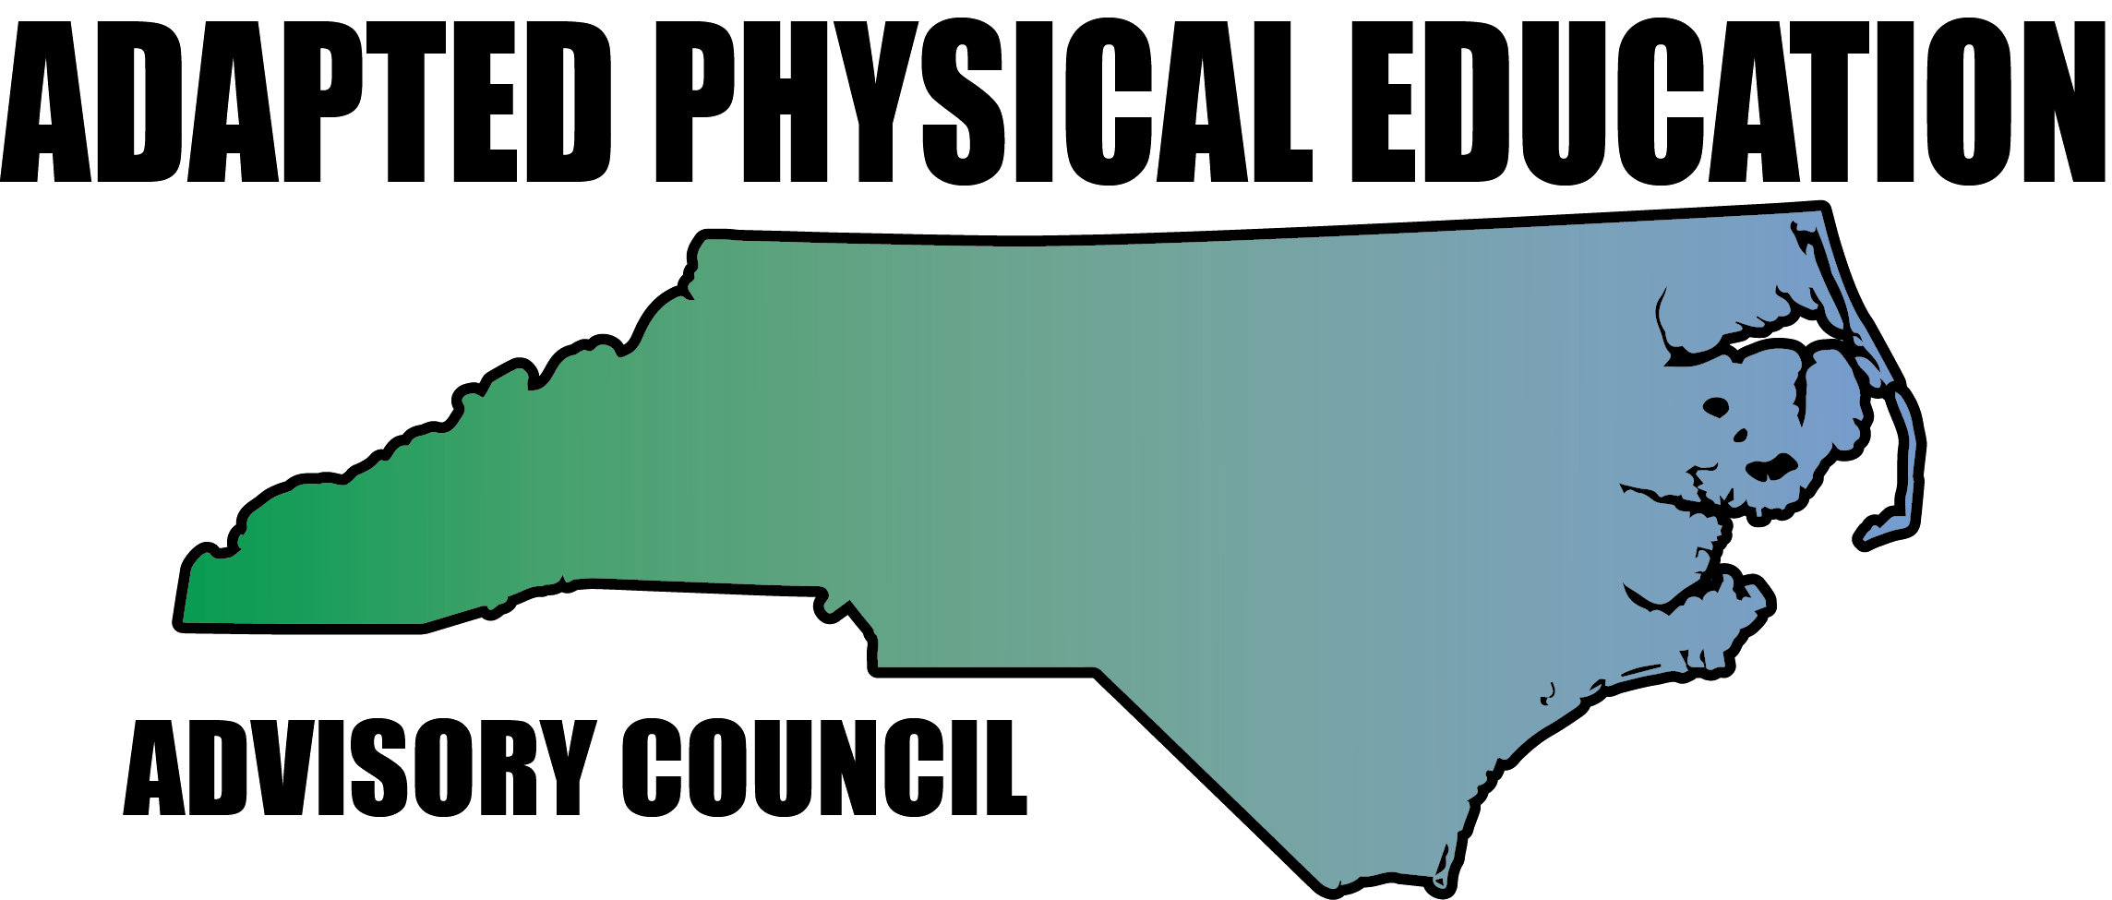

Meeting Minutes

Date: September 15, 2017
Location: Haynes Inman Educational Center, Jamestown, NC
Scheduled Start Time: 9:30
Attendees:
Council Members: Jolanda Hengstman, Barbara Meleney, Lara Brickhouse, Bob Beaudet, Teresa Hudson, Ann Hughes, Tim McMillan, Jennifer Parton, Amy Clark, Megan Davis, Kaky McPeak and Vicki Simmons
DPI: Laurie Ray – Consultant for PT, Medicaid, and Liaison for APE

Barbara called meeting to order.

Celebrations/Announcements
  - Congratulations to LARA for being invited to the Governor’s Council!! This is a first and great for us!! Laurie offered to support Lara with data.
  - Jolanda brought Autism awareness pins left over from the Institute to share with everyone.
  - Jolanda reported that the last issue of Great Activities was missing the APE corner, but she resolved this with Artie so that it should not happen again. This year the deadlines to submit to Jolanda are:
Oct 1st: Kaky
Dec 1st: Amy
Feb. 1st: Lara
April 1st: Kelly

DPI Updates – Laurie
  - DPI is still supporting the APE Consultant position (although it is currently on hold) Laurie said that she is very encouraged. Dreama and Bill are in full support-trying to move forward and problem solve to get position through an LEA by the end of the fiscal year.
  - “Memorandum of understanding”
            - The job description includes: an experienced presenter, knows policy, it will be ½ time-full time, requires a master’s or higher level of education and CAPE certified.
            - Laurie will let the Council know when this position is open to apply for. (should be June 2018 or earlier)
  - APE is now a part of regular monitoring from DPI-they are looking at student data and service time.
  - Laurie is working on a package to have it stated that PE/APE is taught by certified teachers- currently there is no DPI policy.
  - Districts are struggling to find money to support required positions.
  - Laurie is researching what other states are doing to report back to the policy working group.
  - NC has a high rate of obesity/epidemic which helps our advocacy.
  - Looking into having each district be required to have a CAPE.
  - DPI looking at a dual licensure in SPED/PE, but the council doesn’t support this. Laurie strongly suggests to the council: make a position statement with licensure recommendations, what is acceptable, what is not for APE hires. This needs to be submitted to Dreama and Bill Hussey.
  - There is an increase in medically fragile students.
  - School Health Report: We can pull data for our position statement use vignettes “For example” and “If you choose this”.
  - Laurie is pleased with the turn out at the meeting for policy & licensure.
  - IEP: many suggestions being made to the IEP form
- Laurie wants to see them before the pilot begins Jan. ‘18
- There will be 12 schools in the pilot using “ECATS”-exceptional children accountability tracking system-to include: MTSS, IEP and Medicaid reimbursement
- Laurie wants APE to be a curricular area on EASY IEP
- Once it’s past the pilot-that will be it.
  - A new initiative for charter schools is being packaged with the budget for DPI.
- UNC is partnering with related service providers for charters-it’s being rolled out for low incidence (VI, HI, O&M, APE)
- They are conceptualizing this-how would it be staffed? How do they get paid? Keeping kids in their own district and pull from a central hub?

Overview of NC-APE Presentations/Visibility since April 2017
              - Botswana visitors: Bob, Jennifer and Teresa helped 15 folks from Botswana for 3 hours with activities they don’t require a lot of money. Teresa spoke on severe & profound, Gail spoke about health, Jennifer did inclusion and students presented on cross-fit. All that was learned is already being utilized!
              - National PE Institute: Artie came through again with housing, and a free booth with great visibility. All sessions were well attended (20-25) and the booth was well utilized for consulting.
              - Submitted for Lending Library: SPARK Inclusive PE and Tim Davis’ book on disabilities.
              - A BIG THANK YOU to Jolanda for helping with the SPARK Inclusive curriculum.
              - DPI-IEP Writing institute had 25+ participants this past summer-Laurie thought it went well. Given registration numbers, she would be happy to present it again.
              - IEP development with new forms- improving and starting programs in APE: Lara stated that Scott McNamara wants to do a Pod-cast about starting an APE program.

Upcoming NC-APE Presentations

- CAPE session with Tim Davis-was on Sept. 23rd hosted by Jolanda/CMS. CMS custodial services picked up the tab for the Saturday use of the room. We used Google Hangout and it was suggested that maybe we look at holding in-services using this method. Tim was an engaging speaker and it was well received.
- NCAAHPERD-SM: Still no word on our nominations as of 10/6. Please respond the Barbara on your vote for day/time for the council meeting. Lara presents Friday afternoon and the council session is on Thursday afternoon, followed by the awards banquet.
- CEC: APE Institute: Barbara and Jolanda presenting on November 15th from 9-4pm. As of the meeting date, there were already 67 registered, so it will be opened to 100 participants instead of 75. NEEDS: glue guns, tube socks, contact paper, newspapers and egg cartons for the “Make it Take it” portion. If you would like to help-Laurie can get passes for Council member, but you will not get a nametag or be eligible for CEU’s.
- SHAPE Nashville: March 21-24. Barbara, Lara and Jolanda put in to present.
- Council REQUESTS: Laurie is getting req’s for APE technical help- she suggested that the council will need to set up boundaries on what we can reasonably do.
- Innovative approaches (April/May) in Allegheny, Ashe and Watauga Counties looking at inclusive recreation and APE-pairing with APP State Recreation services. Teresa, Jennifer and Bob
- Davidson County wants an AU in-service. Vicki and Tim?
- Scotland County ???

Updates by Region
  - Region 1 – Lara
- Nothing to report
  - Region 2 – Ann and Megan
- Outreach to Brunswick Co.
  - Region 3 – Barbara
      - Barbara will be retiring at the end of the year-there will be two APE opening in Durham!
  - Region 4 – Kaky
  - Region 5 – Tim, Vicki, Ashley
    - Lara gave Tim the name of someone wanting HS curriculum.
  - Region 6 – Jolanda, Amy, Kelly
      - Iredell has reached out wanting an in-service, but it was over the summer when no one was available.
  - AC will continue to explore possible replacement for Region 7
  - Region 8 – Teresa and Jennifer
- Nothing to report

Updates in NC Politics/News: Vicki
- K-3 class size and how it affects specials has stalled out.
- Theresa Thomas of Forsythe Co. came to observe/help Vicki: 26 on HS caseload and no IEP since it is an adapted school.

Website Updates: Megan
  - Logged in and edited 2 times. Will update with link to Openphysed.org and a link to our lending library.

*topics tabled until next meeting at NCAAHPERD: High school and Transition IEP’s and Charter School requirements for PE and APE.

Future Meeting Dates
  - November 2 or 3 at NCAAHPERD Conference

Meeting adjourned 2:30pm Respectfully submitted by: Amy Clark

