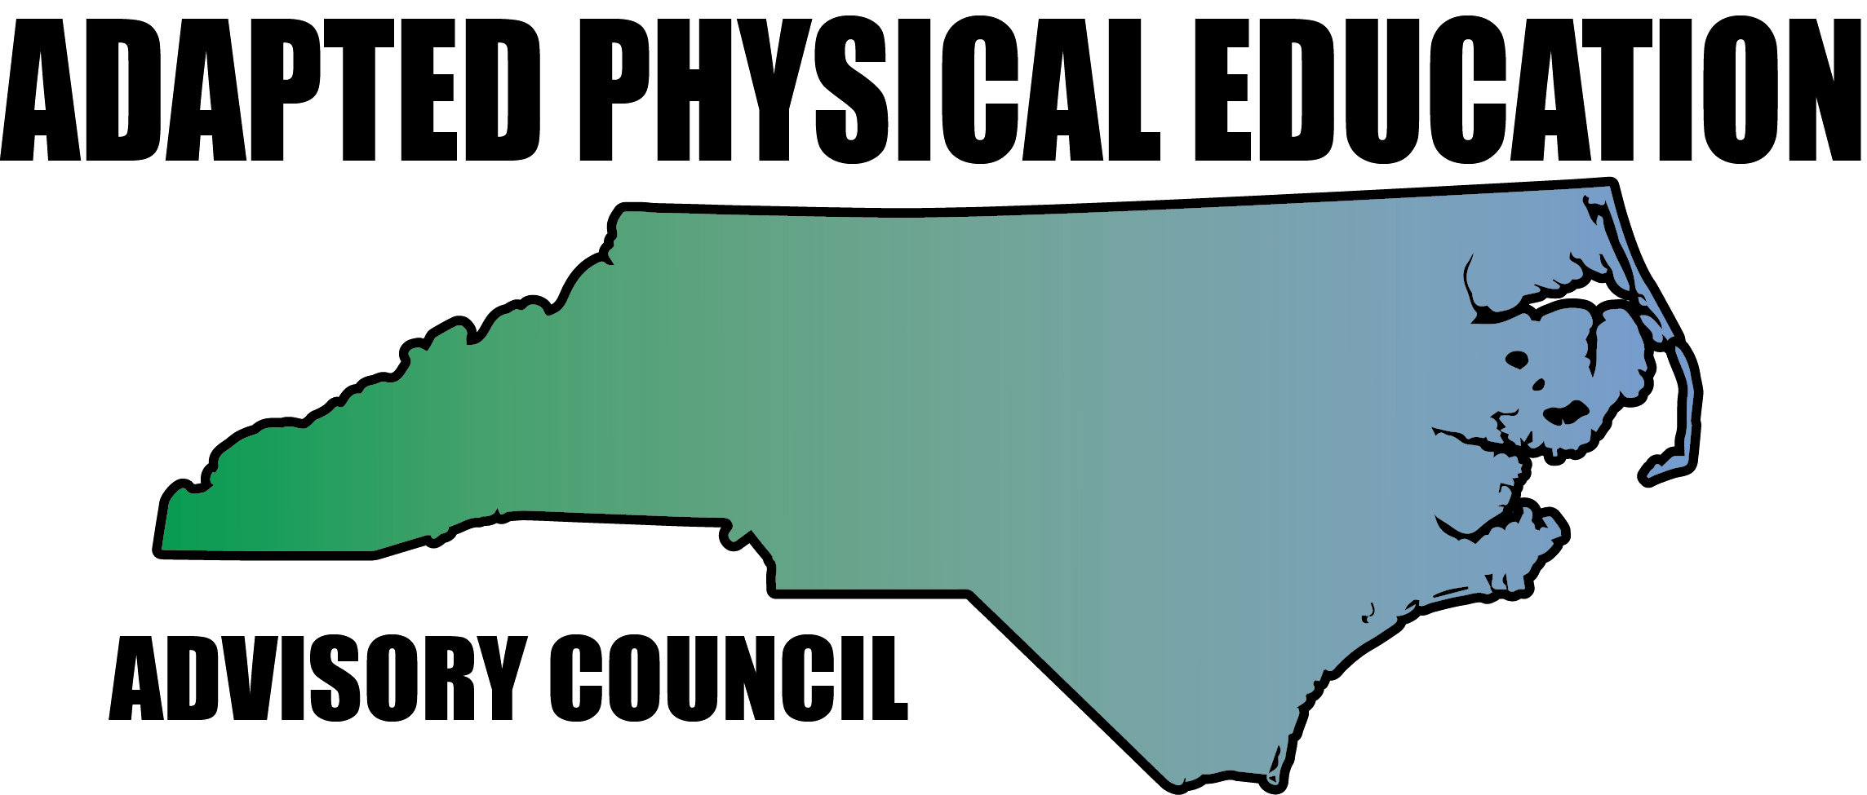

Meeting Minutes

Date: April 28th, 2017
Location: Haynes Inman Educational Center, Jamestown, NC
Scheduled Start Time: 9:30
Attendees:
Council Members: Jolanda Hengstman, Barbara Meleney, Lara Brickhouse, Bob Beaudet, Teresa Hudson, Ann Hughes, Jennifer Parton, Ashlie Beavers, Amy Clark, Megan Davis, Kelly Givens, Kaky McPeak
DPI: Laurie Ray – Consultant for PT, Medicaid, and Liaison for APE
Guests: Brad Burke, APE, Rowan-Salisbury Schools, Morgan Wittman Gramann, Executive Director, NC Alliance for Health

**ACTION Items Color Coded: All AC Individual
**Hyperlinks – Blue, underlined text is linked to additional info; press Ctrl+click link to access.

Jolanda called meeting to order.

- Greetings/Reminders/Quick Updates
  - Congratulations to Lara – 2017 National APE Teacher of the Year!
    - Lara was recognized at the DPI EC staff meeting April 24th, 2017
  - Complete mileage form and send to Melinda Tomlinson at DPI for reimbursement.
  - Latest Great Activities magazine now available – see Barb’s article on Field Day!

- Guest Speaker – Morgan Wittman Gramann, Executive Director, NC Alliance for Health
  - NCAH is an independent, statewide coalition convening and mobilizing partners
to advance equitable health policies that promote wellness and prevent obesity and tobacco use.
  - Ongoing projects:
    - Including PE on the School Report Card
    - Provision of useful information to encourage parent involvement
    - Monitoring and advocating for HB 13
    - Building relationship with NC Superintendent of Public Instruction, Mark Johnson
    - Promotion and support of quality physical education
    - Childhood Nutrition – Healthy Corner Store
    - Advocating for clear messaging on physical education versus physical activity
  - HB 13 Update
    - Senate updated bill – decreased class size allotment by 1 pupil, eventually moving to decrease by 2-3 pupils
    - Still no word on funding from General Assembly
    - Most recent cost estimate = $320 million (I don’t even know how many zeros that is)
          - Only includes cost of teacher hires and employment
          - Does not include funding for additional physical classrooms, desks, chairs, trailers, etc
          - Visit ncleg.net for more information
    - Sign up for NCAH’s listserve – lots of useful, up to date information provided
          - Email Morgan to be added: morgan@ncallianceforhealth
    - All AC: Share information about NCAH with colleagues

- GREAT Activities:
  - AC stepping it up! CHEERS to everyone that volunteered!
  - Encourage colleagues to submit
  - Jolanda will create outline of requirements
  - Upcoming issues:

Deadline | Issue | Responsible Party
August 1st | Sept-Oct | Jolanda
October 1st | Nov-Dec | Kaky
December 1st | Jan-Feb | Amy
February 1st | March-April | Lara
April 1st | May-June | Kelly

- Upcoming Conferences/Presentations – Including Proposal Deadlines:
  - NC A&T APE Workshop
    - Ashlie is presenting APE 101 – Lara will email PPT
    - Roy Sanchez also presenting
  - National PE & School Sport Institute, Asheville, July 24th – 26th, 2017
    - Two proposals submitted – THANK YOU Jolanda!
          - Make it Take it – Jolanda on lead
            - All AC: send ideas to Jolanda
          - Creating Inclusive, Healthy Active Schools – CMS colleague on lead (I think!)
    - Third session decided
          - Specialized Recreation (bowling, bocce, disc golf, etc) – Lara on lead
    - AC will also partner with US Games during applicable presentations to add a little APE flare!
          - Lara will follow-up with USG
  - DPI Summer Institute, Greensboro, July 24th – 28th, 2017
    - APE IEP Development – presented by the one and only Laurie Ray
    - Share with colleagues
          - Lara will share info via website and Twitter
          - Lara will email flyer/info to Dr. An (ECU) and Dr. Elliot (NC A&T) directly
  - NCAAHPERD-SM Convention, Winston-Salem, November 2nd – 4th, 2017
    - Nominations and proposals due July 1st, 2017
    - AC has nominated the following:
          - NC APE TOY – Teresa!
            - Kaky will complete nomination paperwork
          - University – Bob!
            - Jennifer and Teresa will complete nomination paperwork
          - Outstanding Program – Mecklenburg Co. Special Olympics!
            - Jolanda will complete nomination paperwork
    - AC presentations – TBD
  - DPI EC Conference, Greensboro, November 15th – 17th, 2017
    - Institute proposal deadline extended – due May 8th
          - Barb and Jolanda will submit proposal
  - Upcoming LEA Presentations
    - Iredell Co. – Jolanda
    - Watauga, Ash, Allegany – Lara
  - Conference Giveaways – Council SWAG!
    - Did you know – SWAG stands for Stuff We All Get (useless trivia)
    - Amy reported on pricing for magnets, stickers, lapel pins
    - AC decided magnets are a definite
    - Kaky will look into local Sheltered Workshops for less expensive option for stickers

- Treasurer Report
  - Current balance = $451.00
  - Addition since our meeting – the domain for our website (not the website, but the rights to our website name…tech talk is confusing, I know) was renewed 5/8/17.
    - Lara paid $67.90 for 2 years

- Website Report
  - Page Views per Week = 633 (as of May 8th)
  - NC-APE.com is the 5th result in a general search for “Adapted PE” via Google
  - Webpage for Wrightslaw has direct link to NC-APE.com’s FAQ Page
  - Domain name renewed 5/8/17
  - Website renewal 10/2/17 – hard to believe it’s already been TWO years since we last renewed!

- Activity Report
  - Laurie stated importance of Activity Report – data matters!
  - All AC – continue to provide proof/data to Activity Report
    - If you’re not sure whether or not to add something to the spreadsheet, ADD IT! Every little bit counts.
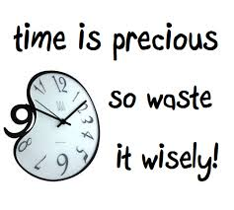
  - Spreadsheet updated 5/7/18:
    - 3 new columns added for presentations:
          - Preparation Time
          - Travel Time
          - Presentation Time

- DPI Updates – Laurie
  - APE Consultant Position – official posting intended for July
  - Laurie continues to request for monitoring of APE through Policy and Monitoring Dept.
    - Does student require APE?
    - If so, are goals present in IEP?
    - Is progress reported?
  - DPI APE Lending Library
    - Being updated with photos and links
    - All AC – send suggestions to Laurie and copy Amy McLemore at amy_mclemore@med.unc.edu
    - Lara will add link to library on NC-APE.com AND Tweet about it
  - Regional EC Director’s Meeting
    - Dreama is working on adding AC to agenda
    - Fingers crossed we make the cut!
  - ECATS – in the works
    - Will replace CECAS and house:
    - IEP forms
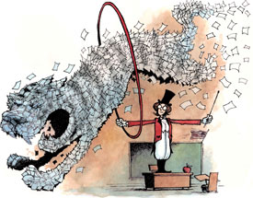
    - Medicaid billing
    - MTSS
  - New/redesigned IEP forms – intended roll out Fall 2017
    - Forms will be combined
    - Format of PLAAFP changing
    - APE listed as Special Factor – increased visibility in dropdown menu
    - Dropdown menu for goal section to include area addressed, goal, criterion, measure for progress, responsible service provider, and more.
    - Post-secondary education now embedded in IEP
  - DPI version of APE Powerpoint in final stages – awaiting approval from Bill Elvey
    - Will be posted on DPI APE webpage
  - Clarification on re-eval process – YIPEE!
    - In order to exit a student from APE, you must go through the re-eval process
    - A formal re-eval (e.g., assessment, eval) is not needed if and only if you have data to support exiting the student.
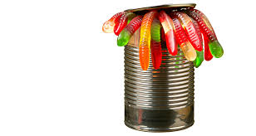
  - Service Delivery/Frequency – can of worms officially open…at least they’re gummy
    - What amount of specially designed instruction is the student receiving?
    - SDI definition
    - Still confused? Request a SDI training from DPI!
  - Potential guidance document on Laurie’s radar:
    - How to provide APE without APE Specialist

- Highlights from the SHAPE America National Convention, Boston 2017
  - SO cold…oh so cold
  - A southern accent goes a long way ;)-
  - APE/PA Special Interest Group Annual Meeting
    - SHAPE Exchange – join a “Community” to stay up to date
    - NCPEID continues to pave the way – great resource
    - NCHPAD – check out the NCHPAD YouTube channel
    - APEAS – new, mobile friendly version rollout intended for fall of 2017
    - Changing culture of PETE and APE Prep Programs – Dave Martinez, Univ. of Georgia
          - Proposal – combine SHAPE Standards + APENS Standards + NCPEID Recommendations to increase student knowledge of diverse learners
  - 2018 National Convention in combination with Southern District
    - March 20th-24th, Nashville, TN

- Regional News/Updates
  - University Level- Bob
    - Group from Botswana visiting WCU for 1 week beginning July 12th
    - Bob will present all things APE and be an amazing host!
    - AC members interested in assisting should contact Bob asap
    - Apparently, Lara thinks Ultimate Frisbee is Botswana’s main sport

- Structure of AC and Elections
  - Jolanda and Barb presented plaques to officers, certificates to members
    - Warm and fuzzy feelings abound!
  - AC will reinstate two tier membership
    - Leadership Team
          - Mandatory attendance at all 4 meetings
          - Manage committees and presentations in their region
          - Voting rights
          - Annual dues = $30
          - Eligible to be elected for office
          - 2 year commitment
    - Membership
          - Mandatory attendance at November and April meeting
          - Actively participate on committees and presentations in their region
          - Annual dues = $20
          - Great Activities article submission
          - 1 year commitment
  - Elections: officers will serve from April 2017 – April 2019
    - Chair: Barb
          - Barb’s platform – free ice cream at every meeting!
    - Vice Chair: Lara
          - Lara’s platform – AC will no longer have to wait a month for meeting minutes!
    - Secretary: Amy
          - Amy’s platform – no more pictures of pigs eating ice cream!
    - Communications: Megan
          - Megan’s platform – she knows more about technology than anyone else in the room!
    - Treasurer: Teresa
          - Teresa’s platform – trust and security…and we know where she lives!

- Future Meeting Dates
  - September 15th, 2017 – Haynes Inman (doesn’t Haynes Inman sound like a character from Cold Mountain?!)
  - November 2nd or 3rd, 2017 – NCAAHPERD Conference
  - February 2nd, 2017 – Haynes Inman
  - April 27th, 2018 – Haynes Inman

Meeting adjourned 3:00pm

