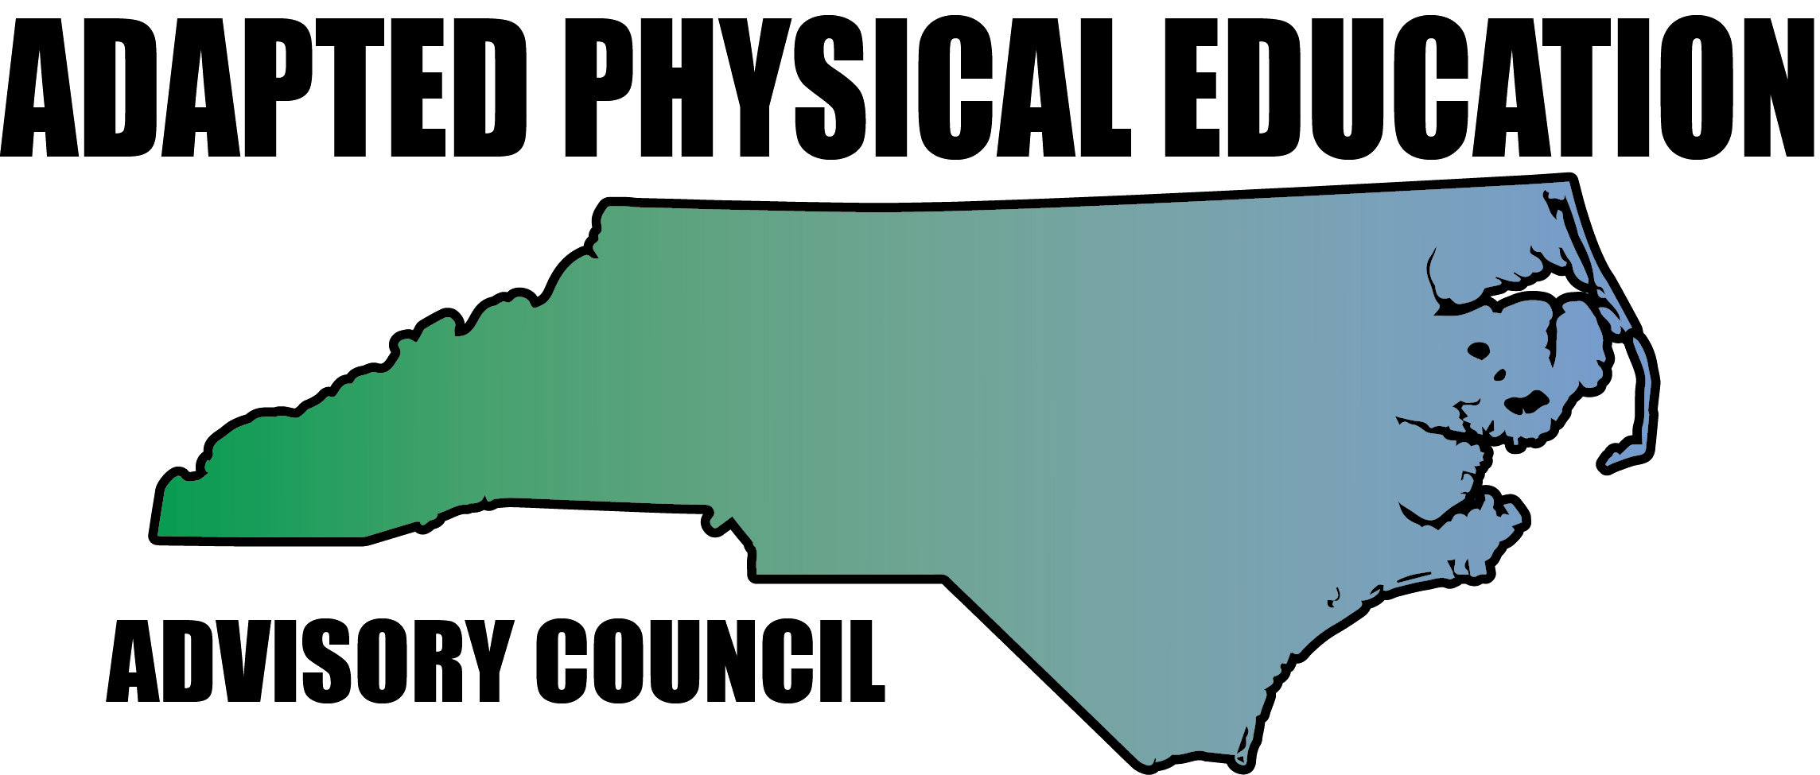

Meeting Minutes

Date: April 27, 2018
Location: Haynes Inman Educational Center, Jamestown, NC
Scheduled Start Time: 9:30
Attendees:
Council Members: Jolanda Hengstman, Barbara Meleney, Lara Brickhouse, Bob Beaudet, Teresa Hudson, Ann Hughes, Jennifer Parton, Amy Clark, Megan Davis, Kaky McPeak, Ashlie Beavers, Kelly Givens, Brad Burke, Amy Stadiem (left early) and Vicki Simmons. Absent: Lara Brickhouse and Tim McMillan.
DPI: Laurie Ray – Consultant for PT, Medicaid, and Liaison for APE

Barbara called meeting to order at 9:51 am.

Welcome/Housekeeping
- Both Barbara (retiring), Jo and Lara (working for an equipment Company and getting BCPS in behavior consulting) are leaving Durham County.
- Thanks to everyone who brought treats for the meeting!
- Jennifer shared the t-shirt design and took orders to be delivered in Asheville or at next meeting. Jennifer is emailed everyone what they owe her-thanks Jennifer!
- CMS is going from 3.6 to 4.0 full time itinerant. Ashlyn left and our new hire is: Doug Smith.

Council By-Laws
- Barb and Kaky are still in the process of tweaking. Board members: Roberts Rules of Orders

Brochure Updates
- Completed with input from the council with Laurie during the meeting.

Overview of NC-APE recent & upcoming presentations:

Fall 2018 EC APE Institute * accepted* (November 14): Kaky and Amy presenting (some repeated information)
- Kaky will tackle the beginners and Amy will do more hands-on with the veteran teachers.
- Will take up to 170 registrants.
- Suggestions: more space, more demonstrations, reserve a portion of the workshop for specific questions.
- Work with Amy McLemore to have technology set up & backed up-help to embed videos into PowerPoint.
- Lara will create a folder on the Drive for videos: people want to see adaptive equipment.
- Laurie had some suggestions:
  - Laurie offered money through DPI for a workshop proposal: 21st century-handouts using email or an APP instead of print outs.
  - Christie Roth’s You Tube channel has lots of videos of activities for severe & profound.
  - She suggests putting in the total number for workshop to try and get a bigger space.
  - Laurie stated that she thinks we are trying to do way too much in one workshop-need to break it down.

- SHAPE Southern district: * 2019 conference is in Tampa on April 9-13*

- Barbara and Jolanda presented a 75 minute make it take it session.
- They had 70+ attendees and all nominees for APE-TOY were present. They received positive feedback: 1-5 scale, the average rating was 4.75 on the overall session.
- Dr. Davis’ session was very good-looked at student’s abilities, not disabilities. It’s PE first-why is APE separated?
- SHAPE exchange: Brad Weiner on line forum-put a link to our website. Send to Laurie to send out to listserv.

- SPELT:
- Megan will do slack lines and balance.
- Lara is not sure she can present on OPEN as it is a conflict of interests with OPEN & Sportime.
- NPEI: July 24-25
- Lauren Lieberman is a keynote speaker (Camp Abilities)
- Inclusion Rating Scale (testing instrument)
- Including VI in PE
- Wants to include “Universal Design”
- We will get a re-cap at our next meeting

DPI Updates – Laurie (some of this is repeated from last meeting, but still relevant)
- We can create on-line modules for Laurie to post on Canvas. Participants can get CEU’s through quizzes, homework and watching videos.
- She has been getting an increase in requests for IEP development/APE (PD available for request)
- Laurie can request funds (like mileage) for workshops.
- Laurie continues to put the APE consultant on her budget (even though it hasn’t been approved).
- She has completed the job description for the APE consultant, but nothing will happen until ECATS is rolled out.
- Laurie suggested doing an APE session on behavior at the DPI institute (90 mins.) We can let Laurie look at it and it could be a collaborative approach to a case study on a child with Autism.
Laurie asked council to review the APE brochure before sharing with Amy at DPI (accomplished at meeting).
Laurie asked council to send her pre-screening/referral forms to her by July 25 * need to get your districts approval and having district logos is ok.
- The APE 101Powerpoint from 2015 has gotten approval from the Policy & Procedures committee. Laurie will send it out via the APE/PT listserv and will have it mentioned at EC meetings. Expectations: CAPE certified-best practice, or currently licensed in P.E.
- Laurie is continuing to talk with Chief Sherrie Vernelson on specific evaluations for itinerant APE teachers.
- There is still talk on DPI having hubs around the state to request support.
- Laurie wants a list of good APE conferences with the cost so she can add it to the APE consultant description.
- We need Extensions standards in PE: Matthew Martinez @ DPI is guiding this policy work. * we don’t even have it for Social Studies or Science yet*
- Position statement with licensure recommendations for DPI (Laurie can use this when advocating)-send to Dreama and cc Laurie. * SHAPE has one-we may want to use this and tweak it*
- Audit process: Making a template for DPI auditors to consider when looking at APE-they only did 2 day fidelity checks-still waiting on results.

- IEP forms:
- Evaluation and re-evaluation on same form.
- APE is not listed as an assessment area.
- APE is not currently on policy.
- APE should be with educational.
- What assessments are commonly used?
- APE not listed under “strengths” *can be updated*
- Academic & participation: If there was not policy to support, it’s not in ECATS.
- Laurie will continue to advocate for APE to be academic. *In the Nov. roll out, APE was an example for an academic area.
- Once we have a policy for APE screening/evaluation, it will be much easier.
- Bill Hussey asked Laurie what happened to the APE Consultant position-she is waiting for him to push it through before he leaves in October ’18.
- DPI Summer Institute is a full day on APE-IEP development on July 23 (overlaps with NCPEI). Amy is attending with two colleagues from CMS.
- Superintendent of Education is pushing on-line learning.
- DPI staff are leaving in droves.
- Laurie sent out ECATS info to the APE listserv: January 2019 is the statewide implementation- as of right now….Will have to upload IEP’s in paper form for the time it is down.
See the ECATS website for information: http://www.ncpublicschools.org/ecats/

Kelly had a question regarding supplementary aids and services. Laurie sent Gaston County info. directly. Laurie said that SDI under consultation is not good.

Barb has a VI student in KI who doesn’t need SDI, just accommodations. Barb is going to exit the student even though the school & EC Director told her that he needs a re-eval. Barb stood her ground-no re-eval is needs is there is sufficient data. “Show me the policy that supports this”.

Dates:
- NCAAHPERD: October 31-November 3.
- CEC short sessions Nov. 15 & 16
- Great Activities submission deadlines: August: Jolanda, October 1: Teresa, December 1: Amy or Doug, Feb. 1: Kelly & April 1: Ann.
- 2018-19 meetings: Sept. 14, Nov. ½ (NCAAHPERD), Feb. 8 & April 5.

Updates by Region:
  - Region 1 – Lara
- Absent, no information.
  - Region 2 – Ann and Megan
- Ann is continuing to work with UNC-W with adapted aquatics.
  - Region 3 – Barbara
- Barbara will be retiring at the end of the year-there will be three APE openings in Durham in July.
  - Region 4 – Kaky
- Gets questions form PT in Hartnett County
- U-Wisconsin get 5 APE courses under their PE degree
- Her Old Dominion contact is looking for counselors for Camp Abilities in Alaska.
- Questions: How can we increase APE classes in NC at the University level? Combined license? Concentration in APE?
- Jolanda asked how non-accredited schools can be handing out degrees when PE should be licensed.

  - Region 5 – Tim, Vicki, Ashley
- 3 schools closed for the remainder of the year due to the tornados.

  - Region 6 – Jolanda, Amy, Kelly
- CMS EC dept. is restructuring
- Gaston Co. had Laurie Ray come out to talk to their district.

  - AC will continue to explore possible replacement for Region 7
- Brad Burke was elected to the council
- Barb suggested that we reach out to school systems in our areas. She will create a form for us to send out.

  - Region 8 – Teresa and Jennifer
- Teresa had a colleague visit ad they have discussed a reciprocal visit and they will look into equipment swaps next year.
- Haywood Co. wants to become a “Unified County”. In October they will host SO staffers.
- Kaky recommended the council recognize our counties that are making an effort with some sort of certificate.

University Update: Bob
- Nothing to report

Updates in NC Politics/News: Vicki
- May 16 is a call to arms to go to Raleigh and march in front of the General Assembly
- There will be a chance to speak to legislators-ask them how PE is taught in their district, what the obesity rate is, and health report card. You can go to: ncleg.net
- Council for Children with exceptional services meets 1 time per quarter and is good exposure to folks like Bill Hussey-great networking opportunity. They finally invited Laurie to a meeting and she presented on APE 101.
- All are encouraged to take advantage of NCATS as a great opportunity to network with others.
- DPI has an on-line directory of schools.
- The General Assembly is discussing putting money aside for “program enhancement teachers”. Not sure if APE is considered one.
- Vicki presented the Council with a 1973 treasure trove of APE/PE films and cassette tapes.
Financial Report: Teresa
- $ 320.25 in the account. Hoping that this time next year we will have a lot more! A discussion was had (at the meeting and via emails) about ordering new business cards. I believe the consensus was to order just enough to get though and wait to see if NCAAHPERD changes names to SHAPE NC.
- Dues: give it a year to see if we can sustain ourselves under the NCAAHPERD umbrella with getting association payments and t-shirt sales.
- To add the website logo to sleeve-$9.00. We will need to up each shirt by $2.50. Shipping is $3 per shirt.

Website Updates: Megan
*Reminder to update the Activity Log on the webpage when you talk to folks who reach out with the time spent.
- If you have anything for the webpage-please send it to Megan or Kelly.
- Brad Weiner has included APE on his weekly posts.

Last minute information:
- DPI is now monitoring APE and they are looking at verification of service delivered, lesson plan, attendance & what you did (worked on: like objective #2)
- Lack of connection between goals & program (goals continuing and not being updated)
- Laurie suggested we send a sample template to DPI progress monitors and HI, VI to see if it will work for them.
- *Kelly will send the form for progress monitoring.

Work Goal: tabled until next meeting
- By-laws work tabled until next meeting.

Future Meeting Dates:
- April 27 is the final meeting for the year.
- Dues due? Not sure….

Respectfully submitted by: Amy Clark

