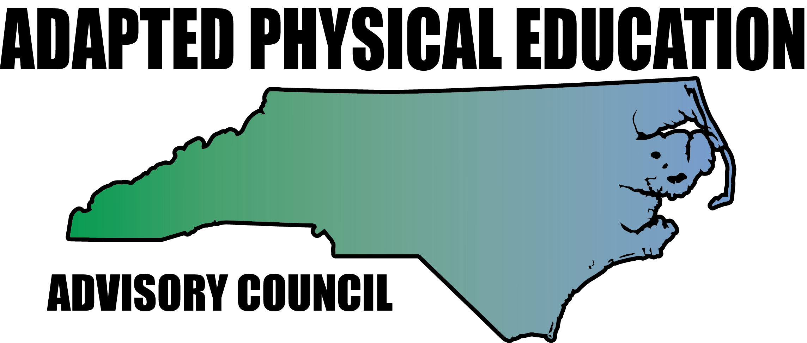

Meeting Minutes

Date: November 10th, 2016
Location: Embassy Suites, Winston Salem, NCAAHPERD-SM Conference
Scheduled Start Time: 11:00
Attendees:
Council Members: Jolanda Hengstman, Barbara Meleney, Lara Brickhouse, Bob Beaudet, Teresa Hudson, Ann Hughes, Tim McMillan, Vicki Simmons, Jennifer Parton, Ashlie Beavers, Amy Clark, Megan Davis, Kaky McPeak

Jolanda called meeting to order.

- Reminders/News
  - Complete mileage form and send to Melinda Tomlinson at DPI for reimbursement.
  - AC congratulated Tim (NC APE TOY) and Lara (Southern District APE TOY)
- NCAAHPERD-SM Happenings
  - NC-APE-AC Booth
    - Lots and lots of traffic! Great networking and chance to share council info – increase awareness.
    - Booth was free for us! Jolanda will send thank you card to NCAAHPERD-SM.
    - Barb passed around thank you card for all members to sign for Artie (NPEI).
    - Lara will post thank you for donations (raffle items) received from Human Kinetics and SPARK, as well as picture of winner.
- Website

  - AC members have shared some GREAT info and resources
    - Consistently averaging over 450 views/week
    - Tim, Ashlie, and Kelli – “Communication Committee”

- Annual Report – Accomplishments and Wish/To-Do List
  - Gentle reminder – update “Activity Report” in Google Drive, as needed.
    - https://docs.google.com/spreadsheets/d/1HhE1jkbTrg1G2n2NiAz1ZandzfhHGbP9BItoPUrar-I/edit?usp=sharing
  - Wish/To-Do List
    - Social Media
        - Website – Communication Committee formed
        - Twitter – Lara will be recruiting (begging) Megan to assist
    - NPEI, APE Institute (DPI), NCAAHPERD-SM
        - AC explored potential presentation topics and manageable work load
          - Bob – Teacher Prep programs at the university level
          - Make it-Take it – extensions to previously presented material
          - Autism/Behavior Management
        - AC discussed teaming up with other presenters/organizations
          - Provide APE expertise – identify how activities presented can be modified for students with special needs
          - Potential contacts/presenters:
            - US Games Presenters Network
              - Pitched the idea to USG and they love it – “Definitely warranted.”
              - Lara will follow up
            - SPARK
            - Bridge II Sport
            - TOYs
            - Etc…
        - Great Activities
          - AC – continue to submit articles to Jolanda
          - Encourage co-workers/colleagues to submit articles
        - CAPE
          - Study session and/or workshop requested
          - Potential for large group (10-20) – NC A&T grad students, AC members, co-workers
          - Jolanda (I think…but could certainly be wrong!) will contact Tim Davis with APENS to request guidance/assistance
          - Kaky pursuing CAPE prep course at college/university level
        - Donations/Sponsors
          - Lara will update website with recent donors
          - Donations/Donors spreadsheet located in Google Drive
            - All AC – update/add info
            - https://docs.google.com/spreadsheets/d/1RhiUcULWtRRxHEqb8Ltj5qATiSSQoP6K02nU5D6mokU/edit?usp=sharing
        - Connecting with NCPEA, Bridge II Sport
          - NCPEA would like to explore the opportunity for a regional presentation on APE
        - Work Groups
          - Still working!
          - Items shared with AC for review/edits and finalized
          - Professional Development Feedback/Survey
          - Host Responsibilities
          - APE Definition
        - Equipment Wish List/Design
          - All AC – add info in Google Drive as you see fit!
          - https://drive.google.com/open?id=0B8jkT_b0U2W_ZjFqUDk0WHM1RUk

- Future Meeting Dates
  - February 3rd, 2017 – Haynes-Inman
  - April 28th, 2017 – Haynes-Inman

Meeting adjourned.

