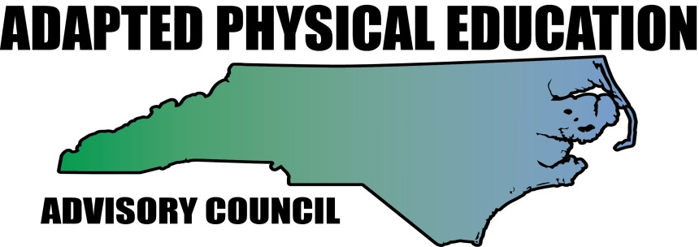
Barbara Meleney, NC-APE-Advisory Council Contributor with permission from:
Sean Healy, Ph.D
Humboldt State University
Arcata, CA
434-284-3047
Sean.Healy@humboldt.edu

The following article includes excerpts from Sean Healy’s article:
ADAPTING EQUIPMENT for TEACHING OBJECT CONTROL SKILLS
from PALAESTRA Magazine (Vol. 27 – No. 4: 2013)

Dr. Healy has graciously given his permission to share “The 5 Ss for Equipment Adaptation.”
#1. SIZE, #2. SOUND, #3. SUPPORT, #4. SURFACE, #5. SPEED
from his PALAESTRA article. The article is filled with creative ways to adapt equipment when teaching object control skills to students with disabilities. Dr. Healy will be adding a 6th S for SWITCHES to his original 5 in a future updated article so that S is also included.

Size 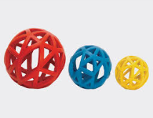All equipment can be adapted in size to allow the user to be more successful. For example, balls can be adapted so the child can throw, kick, or strike more efficiently. For throwing, the ball should be of a suitable size and weight so the child feels comfortable holding it and can easily lift it. For kicking and striking, a bigger ball allows children with coordination difficulties to be more successful, providing them with a greater area of target with which to make contact. 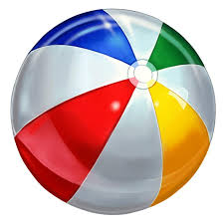 bigger and lighter beach ball 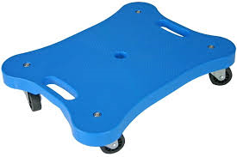 larger surface scooter 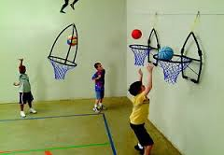 larger and lower goal

The size of nets, basketball rings, bowling pins, goals, hula hoops, poly spots, skipping ropes, and other equipment should also be adapted to suit the child.

Sound Particularly for children with visual impairments, the addition of sound to sports equipment can make a previously inaccessible activity accessible; sound can be added to balls, targets, cones, and other equipment. This can be achieved through the use of security beepers or bells that can be fastened to equipment using Velcro or tape.

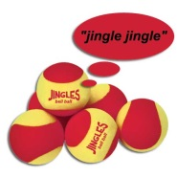 balls with bells 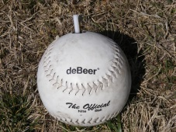 balls with beepers 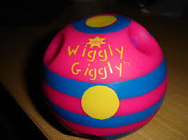 noise making balls

Support 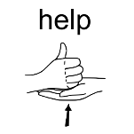This method of adaptation is particularly useful for teaching ball activities; it makes activities less dynamic and increases the child’s chance of success.

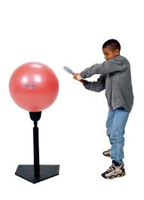 big booper tee 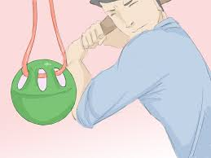 suspended ball 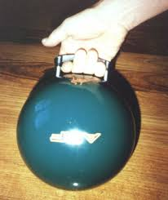 ball with handle 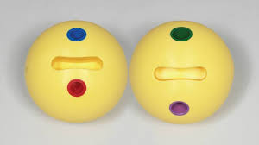 ball with finger slot

For example, to aid a child to practice striking with a bat, you can place the ball on a tee or suspend it with a string. Or equipment could be adapted to provide more access and therefore more readily ensure success, for example, using a bowling ball with a handle or finger slot for students with limited hand strength or fine motor dexterity.

Surface Adapting the surface of equipment can greatly improve its use for many children; for example, adding texture to a ball or the handle of a bat can allow the child to grip it more efficiently. This can be done by wrapping thin rope around an equipment piece and covering it with tape. For children with visual impairments, the adaptation of the surface of equipment is particularly important as it allows them to more efficiently use their proprioceptive skills. 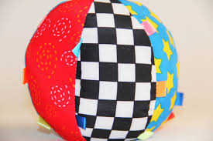 high contrast 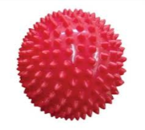 textured 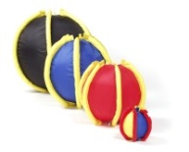ball with handles 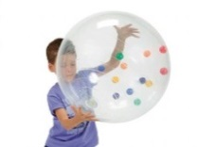sensory ball

The addition of color to equipment will also greatly help some children with visual impairments to see the equipment piece more clearly.

Speed Slowing down the speed of some equipment can greatly aid some children. Balls, in particular, often need to be adapted so that they are slower moving for easier catching, kicking, or striking.

beanbags 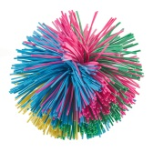 koosh ball 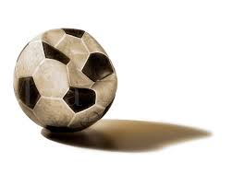deflated ball

Use beanbags or other low bounce equipment that is less likely to bounce or roll when it hits the ground or deflate balls so they roll more slowly.

Switches 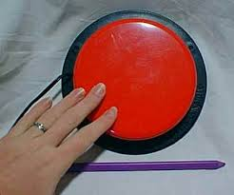The use of assistive technology, like switches, are key to helping students with severe physical disabilities more readily participate in object control skills. Switches allow to students with severely limited motor ability or control to use what they do have to experience the action/reaction phenomenon.

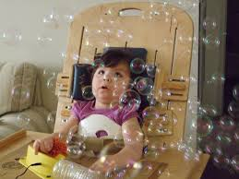 switch activeated toys 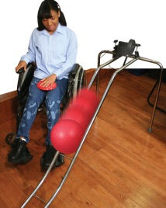switch activated bowling ramp 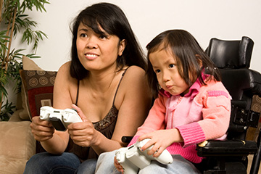remote controlled games

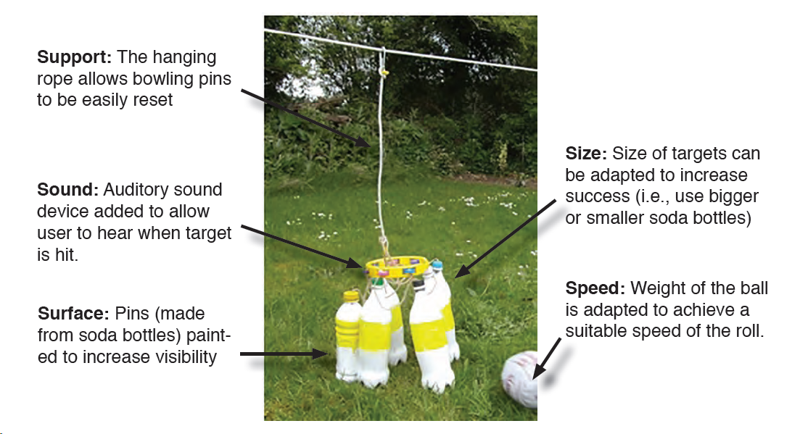
This picture from Dr. Healy’s article illustrates how the five Ss of equipment adaptation can be applied to a game of bowling for a child who is deaf-blind.

