

[www.nc-ape.com](http://www.nc-ape.com)

Ashlyn Morris, Adapted PE Consulting Teacher, Charlotte Mecklenburg Schools

Ashlynm.morris@cms.k12.nc.us

**Our Body Parts- Energizing Health Lesson**

**Materials Needed:** SmartBoard, YouTube Access, Face Puzzle Worksheet, Crayons, Glue Sticks, Scissors, Library Book

1. B-O-D-Y warm up exercises to get our blood flowing:

B- 10 arm circles

O- 10 toe touches

D- 10 mid body twists

Y- 10 jumping jacks

1. Choose a book from your school library and read a few pages dealing with body parts such as eyes, ears, arms, legs, etc. (be creative in choosing a book that is appropriate for your students)
2. Interactive body parts video- Length 4:26- “Body Parts for Kids Learning | Human Body Parts for Kids | KIDS HUT” https://www.youtube.com/watch?v=q4NIEG_ygiM (interact with students during the video)
3. Face Puzzle with class- one worksheet per student- Cut out parts, glue them on, and color (See example below)
4. Review- “Head, Shoulders, Knees & Toes - Exercise Song For Kids” Length- 2:10 <https://www.youtube.com/watch?v=h4eueDYPTIg> (this video incorporates locomotor movements as well as reviewing a few of the major body parts you talked about)

**Example of student work:**

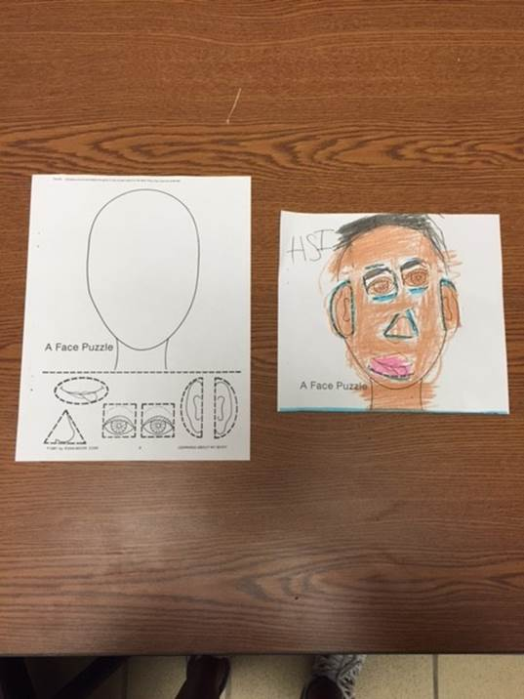

**Modifications:**

* You can modify the exercises to fit the ability of your students, or integrate fitness skills you are working on in class (i.e. push-ups, sit ups, trunk raises, cardio, etc)
* Let your students take turns reading from the book you choose
* Trace the cut outs on the face puzzle with a highlighter to make them stand out in color

**\*\*See next page for 2 additional lessons that would turn this into a UNIT!\*\***

**Our Internal Organs**

**Materials needed:** SmartBoard, 6’ piece of bulletin board background paper, markers, library book

1. O-R-G-A-N-S warm up exercises to get our blood flowing”

O- 10 push ups

R- Jog in place while singing a tune or for time

G- 10 lunges each leg

A- 10 hops each leg

N- 10 dips (using your desk or bleaches)

S- 15 mountain climbers

1. Pull up this image and talk about the 4 internal organs with class then have 1 student at a time come up to the SmartBoard and draw a line from the organ to its matching description- Human Organs Image- <https://s-media-cache-ak0.pinimg.com/564x/76/6f/ac/766fac86fae54dd760166b8b486ab3b0.jpg>
2. Lay out bulletin board paper and have a student lay down and trace their body. Have your class draw the 4 organs on the poster: brain, heart, lungs, stomach/intestines. Then the class can color the image or name it. Here are colored images you could also use to display on SmartBoard for the students to view- Internal Organs- <https://thumbs.dreamstime.com/z/internal-organs-28464337.jpg>
3. Review by reading a book or watching a video about our body’s internal organs and what they do.

**Examples of student work:**

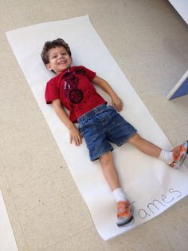 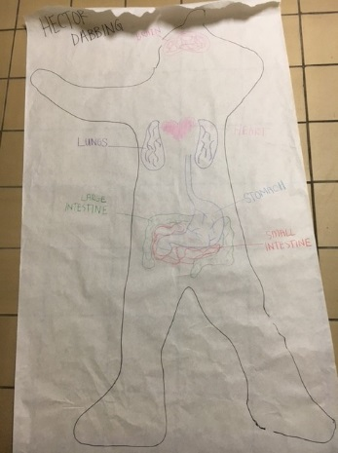 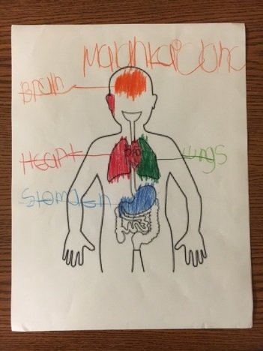

**Modifications:**

* You can modify the exercises to fit the ability of your students
* Don’t recreate the wheel! There are a TON of images on google to help you teach the internal organs. Stay simple or get as in-depth as you would like!
* Have students work in groups (small or large)
* Print out the organs for them to cut out and glue on versus drawing

**The Skeletal System**

**Materials:** SmartBoard, YouTube access, Skeleton poster board, Matching worksheet, skeleton stock cards, library book

1. S-K-E-L-E-T-O-N warm up exercises to get our blood flowing

S- 10 squats

K- 10 stationary jumps

E- 5 high fives with friends

L- 1 minute of skipping in place

E- 10 crunches

T- 20 air punches

O- 10 crisscross jumps (arms and legs)

N- 10 knee lifts

1. Overview of skeletal system using a poster/picture. Choose a poster or image that has factual information to share that is appropriate for the level of your students. (Use Google as a free resource and put a picture up on a SmartBoard or projection screen).
2. Matching worksheet- one for each student. (See image below)
3. Buy, make, or cut out skeleton puzzles. Divide class into 2 groups and have them compete putting the skeleton together in a relay race fashion. Compete a few times. (S&S Discount is endorsed by PE Central and has a Skeleton Foam Floor Puzzle for $29.99)
4. Stand up and move your body to the dance- “The Skeleton Dance”- Length 1:57- <https://www.youtube.com/watch?v=e54m6XOpRgU>
5. Read your library book of choice dealing with the skeletal system.

**Examples of student work:**

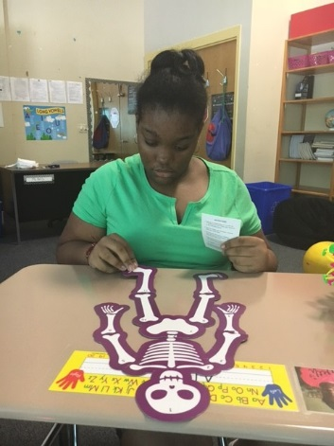 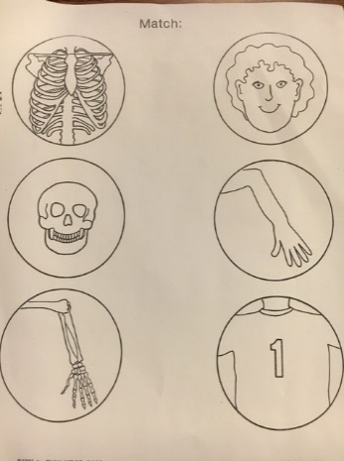

**Modifications:**

* You can modify the exercises to fit the ability of your students
* Have each student research a bone and let them come up and tell the class about their bone
* Matching worksheet difficulty can vary. The one shown was used for K-2. There are many printables online for free!