www.nc-ape.com
Jolanda Hengstman, CAPE, NBCT
Adapted Physical Education Consulting Teacher
Charlotte-Mecklenburg Schools
Jolanda.hengstman@cms.k12.nc.us

Bocce, from skills practice to game play.
The following is a description of how we use Bocce to create training and competition where ALL students, regardless of their ability level, can participate in a meaningful way.
The goal of Bocce is to toss the bocce- ball (ball) underhand as close to the target (palina) as possible. All lead-up activities keep this goal in mind.
Let’s discuss the game first and break it down from there:
- 4 heavy balls
- Set distance, court is 60-65 feet long and 10 feet wide on short grass or gravel.
- Rules
- Two players or two teams against each other.
Each can be adjusted without compromising the goal: getting the ball close to the target.
- Balls: lighter, smaller
- Distance: closer, smoother surface
- Rules: use of ramp or pusher to move the ball forward
- Teams: Each student for their personal best
This resulted in the following skills (competition) options:
- Ramp-bocce. Using a ramp (gutter) to deliver three smaller, lighter balls in the direction of the palina. Palina is at 10m for our competition. The surface is smooth such as a parking lot, outdoor shuffle board court, gym floor, hall way etc. We measure the distance of the nearest ball to the
Palina to determine the score for that turn.
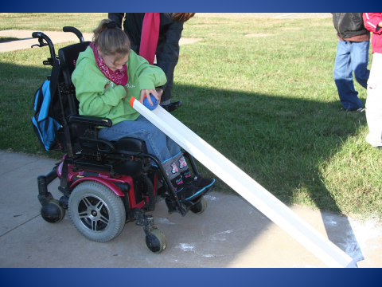

- 10m skills. Students toss (underhand) three smaller, lighter balls towards the palina. We measure the distance of the nearest ball to the palina to determine the score for that turn. All three balls get picked up and the following student tosses the balls. It is still a smooth surface.

- 15m. skills. Students now use the regulation bocce balls on the grass or gravel court.
This means the balls are larger and heavier and the court not so smooth, i.e. the ball doesn’t roll very well, it has to be tossed. The student gets three balls and the distance of the one nearest to the palina gets measured. All three balls get picked up and the following student tosses them.

- Team play. For team play each student should have the following suggested skills:
- Looks at the palina before tossing the ball. Doesn’t just release the ball because he was told to.
- Tosses the ball past the midline consistently, and ball stays in the court.
- Stays with the team and takes turns.
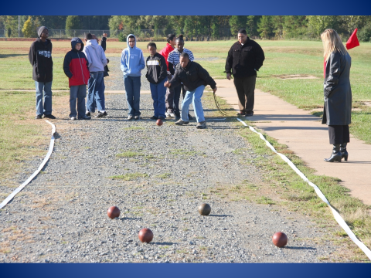

Simple team competition rules:
- Each team (1, 2, or 4 person team) has 4 balls of the same color, the other team has 4 balls of an opposition color. Official bocce sets are red and green.
- Both teams are at the same end of the court
- Start: (coin toss to decide which team goes first). The player tossing the first ball stands behind the foul line (2 big steps from the end of the court) and tosses the palina. The palina has to land passed the midline and before the foul line on the other end of the court. All throws are underhand.
- The same player then throws the first bocce ball trying to get as close to the palina as possible. This is now the “in-ball”.
- The players on the opposing team take turns to toss their color balls until one of their balls becomes the “in-ball”. This can be the 1st, 2nd, 3rd, or 4th ball.
- If the opposing team gets a ball closer (one of their balls becomes the “in-ball” the turn goes back to the starting team.
- Switch turns ONLY when a team rolls a ball closer than their opponent’s closest ball (when they get the “in-ball”) until all 8 balls have been thrown.
- The team with the closest ball gets 1 point for that ball and 1 extra point for any other ball that is closer than the closest ball of the opposing team (max. of 4 points per frame).
- No points if both team’s closest ball is the same distance from the palina.
- The team receiving the points starts the next frame, and gets the palina. This frame is played from the other end of the court after each player retrieves their game ball. If it was a tie, no points are awarded, and the team that threw the palina last will do so again.
- The start of the game alternates between one end of the court and the other end of the court.
- Special Olympics Mecklenburg County
- Bocce Skills Score Sheet

- Record score in centimeters (example 45 cm, or 215 cm)
- 3 balls per turn, 3 turns total. Measure only the closest ball to the pallina for each turn.

- (Competition) date: ______________ Heat/Group: _________________
STUDENT | 10 METER | STUDENT | 15 METER | STUDENT | RAMP -10 M
 | 1.  2.  3.  Total= |  | 1.  2.  3.  Total= |  | 1.  2.  3.  Total=
 | 1.  2.  3.  Total= |  | 1.  2.  3.  Total= |  | 1.  2.  3.  Total=
 | 1.  2.  3.  Total= |  | 1.  2.  3.  Total= |  | 1.  2.  3.  Total=
 | 1.  2.  3.  Total= |  | 1.  2.  3.  Total= |  | 1.  2.  3.  Total=

