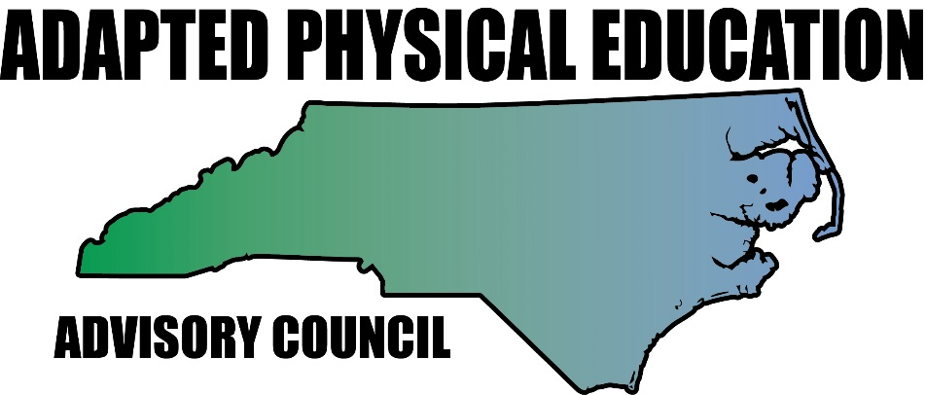www.NC-APE.com

Striking made possible for ALL students.
A compilation of ideas from the book: Movement ABCs by Jolanda Hengstman
Member of the Leadership Team of the NC Adapted PE Advisory Council

Reasons to make adaptations:
- Increased level of success and independence.
- Increased time on task and active participation time.
- Differentiation to facilitate teaching and learning for all students.

Implements:
- Hand
- Short handle racket
- Large foam hand or mitt
- Table tennis paddle
- Light weight bat, large bat, flat bat
- Splatter guard
- Use Velcro straps or the commercially available grip-mitt to secure implement to student’s hand or arm.

Table tennis simplified (goal: keep the ball on the table):
- This can be any ball (larger, slower rolling, non-bouncing) on any table.
- Sides of the table have pool noodles or boards attached. Pool noodles can be taped down, or 2x4 boards are placed (no need to attach) to prevent ball from rolling of the side.
- Take the net off and it is easier to get the ball back and forth, compare to air-hockey.
- Student can sit, stand, or roll up to the table in a wheelchair.

Racket/batting –T with attached ball/balloon (goal: strike the ball in a specified direction for a certain distance):
- Use non-elastic rope.
- For larger balls use a bopper or an upside down plunger stuck into the batting-T or top of the cone (see picture).
- Ball cannot roll away.
- Student can retrieve own ball, increased independence.
- Provides continuous practice.
- Use foot prints when teaching striking technique.

Suspended equipment (goal: strike the ball in a specified direction a number of times in a row):
- Provides differentiation for height (declining height), equipment, and activity.
- Use non-elastic rope (elastic bounces making the path of the object unpredictable).
- Can use tennis balls, wiffle balls, balloons, etc.

Safety: pick up balloon pieces after the balloon pops !

