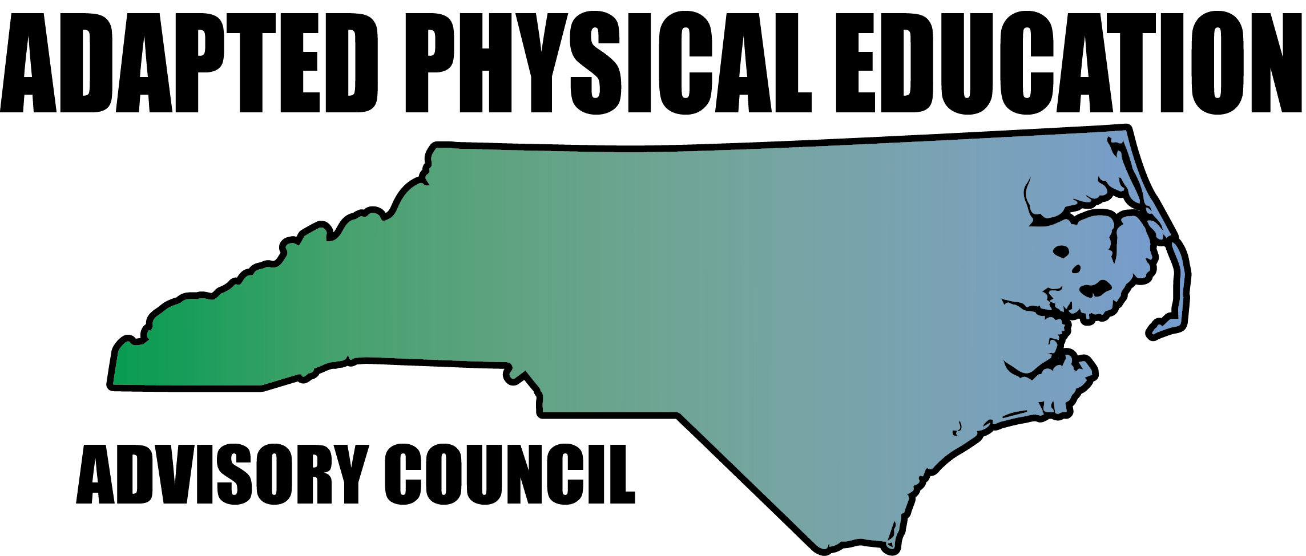

Meeting Minutes

Date: September 23rd, 2016
Location: Haynes Inman Educational Center, Jamestown, NC
Scheduled Start Time: 9:30
Attendees:
Council Members: Barbara Meleney, Jolanda Hengstman, Ann Hughes, Vicki Simmons, Bob Beaudet, Teresa Hudson, Tim McMillan, Lara Brickhouse
DPI: Laurie Ray – NC DPI EC Division, PT Consultant, Adapted PE Liaison (1:00 via phone)

**Hyperlinks – Blue, underlined text is linked to additional info; press Ctrl and click link to access.

9:40 – Meeting called to order.

- Sharing of Activities/News/Region Updates

Congratulations to Tim – NCAAHPERD-SM APE Teacher of the Year!

  - Region 1 – Lara Brickhouse
    - Presented to NC A&T graduate students enrolled in - “PAPERS” (Preparing Adapted Physical Educators to Render Services).
    - NC A&T has requested workshop/study session for APENS exam.
      - Kaky is AC contact for APENS and has been in touch with NC A&T to plan…Lara will follow-up with Kaky.
    - Extended invite to AC meeting to Stephanie Little and Chris Walker of NCPEA. Both had prior obligations, but have enthusiastically agreed to assist and support the NC-APE-AC if/when needed.
      - Lara will send upcoming events and related info to NCPEA and request that info is shared.
    - Emailed Dr. Jihoun An (APE professor @ ECU) regarding current research topic:
      - “The aim…is to re-design an APE course to prepare pre-service PE teachers to be an inclusion specialist and explore their experiences of the course.”
      - Research Abstract is posted in University Level APE folder in Google Drive.
    - The NC-APE-AC has a Twitter handle! @NCAdaptedPE
      - Feel free to follow, edit, contribute, etc! Twitter support needed!
      - Social icon, news feed, and Twitter links have been added to website.
  - Region 2 – Ann Hughes
    - Onslow Co. requested PD from AC, but has not contacted Ann since.
      - Update (10-10-16): Greg Grantham, Healthful Living Coordinator for Onslow Co, requested Oct. 20th APE PD from Dr. An @ ECU.
      - Dr. An is unable to attend, forwarded email to Ann and Lara to request assistance.
      - Ann shared APE Institute flyer and encouraged Onslow educators to attend.
      - Lara or Ann will follow-up with Grantham.
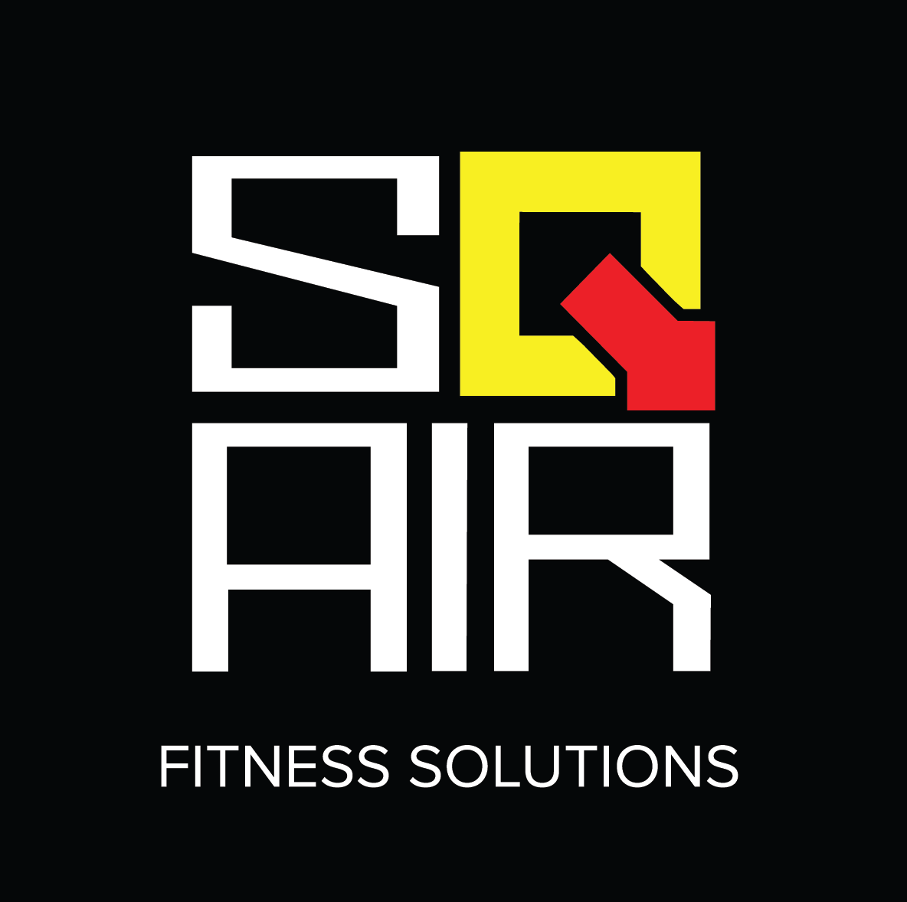
    - Met creator of SQAIR, Jade Ng, at NCPEI – Jade graciously donated two “Sqairs” to AC. Ann is currently using them in New Hanover Schools.
      - SQAIR is the “Featured Equipment” on our website along with a “Shout Out” to Jade Ng, SQAIR’s creator! You scratch my SQAIR back, I’ll scratch yours!
    - Presentations at UNCW: Adapted Aquatics x 3, and APE service delivery/collaboration.
  - Region 3 – Barbara Meleney
    - DPS APE crew presenting to elementary level PE teachers:
      - Teaching PE to Students with Autism.
    - NCCU students attending APE classes as part of practicum.
    - Disconnect between university level professionals and APE Specialists
      - Bob will contact university level professionals
      - Possible meeting at NCAAHPERD-SM Conference?
  - Region 4 – Kaky McPeak
    - Kaky was unable to attend meeting.
  - Region 5 – Tim McMillan
    - Piedmont School (Private) has requested APE PD
      - Tim will follow-up
    - GCS APE crew met with supervisor – outlook for next year is to maintain same amount of APE Specialists (8).
      - Estimate – 450 students with APE in IEPs.
    - Caseload numbers continue to climb
      - Carol Ann Hutchins is open to meeting about this.
      - Tim and Vicki will head up this committee.
    - Dreama McCoy (DPI) has requested to attend council meeting. Vicki will follow-up?
    - Vicki presented to NC A&T graduate students enrolled in - “PAPERS” (Preparing Adapted Physical Educators to Render Services).
    - Haynes Inman Indoor/Outdoor Adventure Day is November 1st!
      - Vicki – please share photos or coverage to post on Twitter and website.
  - Region 6 – Jolanda Hengstman
    - CMS APE has a Facebook Page in addition to info on the CMS Healthful Living website.
      - Links have been posted on our website!
    - Ashley Thomas (Bridge II Sports) is in need of schools for the Adapted Sport Program.
      - See email from Ashley or contact Jolanda for more details!
  - Region 7 – Vacant (formerly Stanley Rogers)
    - No update
  - Region 8 – Teresa Hudson
    - Charter school in Buncombe Co. requested Teresa’s assistance with APE evaluation and related IEP goals.
    - University update from Bob – Still working on comprehensive list of APE contacts at the university level. Will use gathered info to network and advocate for APE.
      - Has identified a need for assistance with APE practicum programs.
      - Will reach out to university professors.

- Review of Minutes and ACTION Item Updates
  - ACTION Items/Ongoing Projects from AC:
    - Grants – Workgroup: Kaky, Jolanda
      - Jolanda never heard back about the Friends of NCAAHPERD-SM grant.
      - Due date for this grant is typically in June or July…not good timing.
    - Host Responsibilities – Workgroup: Jolanda/Lara
      - Lara will send to AC for edits/final approval asap.
    - Unifying Forms – Workgroup: Ann, Amy and Lara
      - Forms are/will be unified as the APE Handbook is developed.
    - University Connections – Workgroup: Bob
      - All AC – add university level APE contacts to University Level APE folder.
    - EC Director Starter Kit – Workgroup: Barb, Amy, Tim
      - Laurie suggested asking EC directors in LEAs that do not have APE specialists what they need/want to know.
      - Update coming soon.
    - APE Handbook or APE Manual of Best Practices: Workgroup: Lara, Jolanda, ??
      - Manual would be specific to NC and include council “publications”
      - More work to be done! No timeline established.
    - Great Activities – All
      - Nov/Dec: Ashlyn (CMS) submitted Body part lesson.
      - Jan/Feb deadline December 1st
      - March/April deadline February 1st
    - US Games Partnership – Lara
      - US Games provided tons of equipment for AC at NPEI!
      - Lara has requested two duplicate bags for AC - East, Central, and West

      - All – Access the US Games Equipment folder in Google Drive and provide ideas/suggesstions for:
        - Equipment Design/Modifications: ideas for equipment that is not in existence, but should be, OR equipment that US Games does not have, but should.
        - Equipment Wish List: additional equipment needs for professional development/conference presentation bags.
          - If you would like to know what we currently have, email me.
    - Record Keeping: Donors/Donations – Teresa
      - Need to track donors and/or donations

      - Lara will create spreadsheet in the Drive folder
        - Will email council for additions/input
      - When spreadsheet is updated, Teresa will maintain upkeep.
    - Activity Report – All
      - We’re working hard! Let ‘em know!
      - Laurie’s working overtime! Let ‘em know!
      - All – add any and all information to the Activity Report – 2016 spreadsheet located in the Council Reports folder:
        - If you’ve provided assistance, consultation, workshops, emails, phone calls, etc related to APE in NC, jot it down!
        - Requested due date: October 20th, 2016

- Presentations, Conferences, and Professional Development
  - Regional Presentations from AC – APE 101:
    - When approved, the “Host Responsibilities” document will be added to informational flyer.
      - Lara/Jolanda will email flyer when ready for distribution, AC will send to:
        - EC Directors (email addresses not accessible)
        - DPI Regional Consultants
        - NCAAHPERD-SM Regional Representatives

  - National PE and School Sport Institute, Asheville, NC, July 25th – 27th
    - SUCCESS! AC provided:
      - Make it Take it
      - Teaching Autism to Students with Special Needs
      - Teaching Sports the Differentiated Ways
      - Unified Sports
    - Bridge II Sports – Sit Volleyball, Boccia, WC Basketball, Goalball, and Legislation Updates.
    - 2017 NPEI – AC to explore additional presentation avenues:
      - Possibly tag-team with other organizations to provide APE guidance/input
        - Bridge II Sports
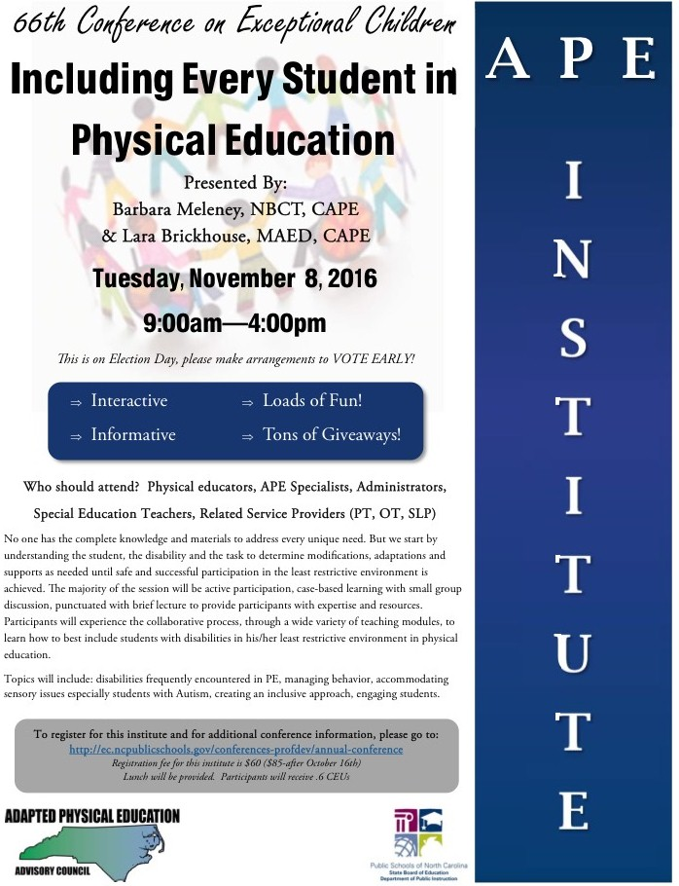
        - US Games Presenters Network
        - Exercise Buddy
        - And more!
  - APE Institute – November 8th from 9:00-4:00
    - At the 66th Conference on Exceptional Children – DPI EC
      - Special thanks to Laurie for pushing this to the front burner!
    - Barb and Lara are presenting as AC reps:
      - AC support and assistance is greatly appreciated!
    - All – please distribute informational flyer to any and all!
      - Attached to meeting minutes email
      - Link is posted on website
  - NCAAHPERD – SM, Winston Salem, NC, November 9th – 12th, 2016
    - Thursday, November 10th:
      - AC Booth: 8:00 am until……
      - AC Meeting 11:00-1:00
        - Jolanda will email location
      - AC Presentation @ 2:15-3:15 – APE Forum: The State of APE in NC
      - Award Ceremony @ 4:45-6:00 – Celebrate Terrific Tim!
    - Friday, November 11th (Holiday)
      - AC Booth: All day

- Treasurer Report (Sunshine Fund): Teresa
  - AC currently has $211 in account
    - Annual fee schedule adjusted:
      - All members $20/year
      - Send to: Teresa Hudson
339 Mills Gap Road
Asheville, NC 28803

- Website Update: Lara
  - Communication committee has been formed. Woohoo!!!
    - Tim, Ashlie, and Kelly have offered their assistance!
  - NC-APE.com stats:
    - Averaging 483 views per week as of 10/11/16
  - Website Updates: Lots of stuff added to website, ongoing process!
www.NC-APE.com

Break for Lunch 12:00
Meeting resumed 12:38

- DPI EC Update: Laurie – via phone 1:20pm
  - IEP Info
    - Forms Revamped: Tentative rollout – Fall 2017.
    - Monitoring – Laurie has met with Carol Ann Hutchins
      - Providing input related to compliance/monitoring
      - Various LEAs have identified APE as area of need for PDs
  - PE/APE Licensure
    - AC will advocate for mandated licensure in PE to teach APE
    - Laurie spoke to Burt about APENS certification recognition:
      - Will follow-up with him in January.
      - CAPE certification – “Best Practice”
  - APE Presence - DPI
    - Laurie continues to advocate and identify need for an APE consultant,
    - Advocating for a contracted position may increase chances,
    - Supporting info needed:
      - NC-APE-AC Activity Report – 2016

      - Statement of need/support,
      - Website info/stats,
      - Participant evaluations from AC presentations
        - Lara will share draft with AC for edits asap.
  - North Carolina Council of Administrators of Special Education (NC CASE)
    - Professional educational organization affiliated with the Council for Exceptional Children and the North Carolina Association of School Administrators.
    - Possible presentation opportunity for AC – Lara will contact Laurie/Teresa Owens to inquire
  - APE Job Assessment (Teacher Eval)
    - Evals for itinerant specialists are not appropriate
    - Partner with other itinerant, special service instructors (HI, VI, home bound)
    - Laurie will request assistance from AC in near future.

- Future Meeting Dates
  - November 10th @ NCAAHPERD-SM Conference
  - February 3rd
  - April 28th

Meeting adjourned 3:00 pm.

