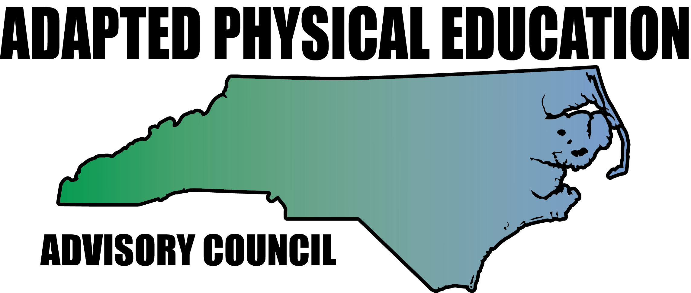

Meeting Minutes

Date: May 20th, 2016
Location: Haynes Inman Educational Center, Jamestown, NC
Scheduled Start Time: 9:30
Attendees:
Council Members: Barbara Meleney, Jolanda Hengstman, Ann Hughes (1:00 departure), Vicki Simmons, Bob Beaudet, Teresa Hudson, Tim McMillan, Amy Clark, Lara Brickhouse, Jennifer Parton
DPI: Laurie Ray – NC DPI EC Division, PT Consultant, Adapted PE Liaison (12:00 arrival)
Guests: Jihoun An – Assistant Professor, East Carolina University and Stephanie Shoaf – APE Specialist, Davidson Co.

**AC = Advisory Council (all members) LT = Leadership Team
**Hyperlinks – Blue, underlined text is linked to additional info; press Ctrl and click link to access.

9:48 – Meeting called to order.

- Sharing of Activities/News/Region Updates
  - Region 1 – Lara Brickhouse
    - Lara presented to Special Education and Psychology majors at High Point University – presentation focused on basics of APE, Orthopedic Impairment, and APE IEP documentation. Presentation was very well received, HPU professor (Teresa Owens) is extremely supportive of APE in NC and continues to advocate for APE as a profession.
    - Currently serving as a board member for the NC Physical Education Association (NCPEA) – attended most recent meeting (April 30th)…more info below.
    - Search for Region 1 representative continues. Lara has emailed various contacts in search of a replacement and will continue to reach out to surrounding counties. Dare Co. follow-up recommended (2/26/16 meeting minutes).
  - Region 2 – Ann Hughes
    - Efforts to revamp APE in New Hanover County School’s continue! Next step – review by EC Director. Following actions – all gathered APE resources will be added to NHCS Google Drive website. Ann’s task force has worked overtime to move APE to the front burner in NHCS! Additional APE position? Let’s hope so…for Ann’s sake!!!
  - Region 3 – Barbara Meleney
    - DPS APE crew has presented to elementary PE teachers at PLC meetings: APE 101 and modifying Field Day activities. Barb and Lara will present “Teaching PE to Students on the AU Spectrum” in August of 2016. In-service trainings are provided during Elementary PLC meetings. Now, how to get to our middle and high schools friends…hmmmmmmm……
  - Region 4 – Kaky McPeak
    - Kaky was unable to attend meeting.
  - Region 5 – Tim McMillan
    - Numerous attendees working in Charter Schools requested assistance at last year’s NCAAHPERD-SM conference, but Tim has not been contacted since.
    - Tim will send AC Professional Dev. Flyer (when finalized) to NCDPI Charter School Contacts, Kevin Allen and Rob Mcouate.
    - Update from Vicki:
      - Vicki nominated Tim for APE TOY.
      - Haynes Inman, NC School of Character award winner, will try for national school of the year next year.
      - Camp High Five @ Haynes Inman 6/20-6/24
        - Focus: increase use and strength of non-dominate hand/arm…camp participants will have their dominant hand/arm casted for all five days of camp! For more information contact camp coordinator, Jenny Young at rjyoung1@aol.com.
      - Invited Barb and Ann to present on AU in Guilford Co.
      - Vicki attended the Sport Education/Health Education workshop from NCPEA Saturday, May 14th, and thoroughly enjoyed it! Lots of information provided, very knowledgeable presenters, well organized event.
        - NCPEA is working overtime to improve PE throughout NC…this was the first of many regional workshops to come from NCPEA. For more information, contact NCPEA President, Stephanie Little, littlest@meredith.edu.
      - NC A&T – received funding to put towards APE program.
      - APE Specialist positions in Guilford Co. Schools will be cut from 8 to 6 beginning in the 2016-2017 school year.
  - Region 6 – Jolanda Hengstman
    - Charlotte-Meck APE Crew has been busy with Special Olympics, pre-k evaluations, and organizing info for CMS Healthful Living website, www.cmshpe.com.
    - Jolanda has taken the reigns for NPEI – collaborated with Artie Kamaya and Bridge II Sports to determine APE presentation needs at 2016 conference.
  - Region 7 – Vacant (formerly Stanley Rogers)
    - Jolanda reached out to Iredell-Statesville Schools – two regular ed PE teachers have been placed in APE positions.
    - CMS APE folks will explore replacements for Region 7 representative.
  - Region 8 – Teresa Hudson
    - Busy time of the year, but all is well in the mountains.
    - Jennifer reports that the EC Director in her county (Haywood Co.) is extremely supportive of APE. She has advocated for our council, and encourages staff to contact the AC if assistance is needed.
    - University update from Bob – Still working on comprehensive list of APE contacts at the university level. Will use gathered info to network and advocate for APE.

- Review of Minutes and ACTION Item Updates
  - We have a lot going on right now and need to tie up loose ends!
    - Biggest help – time at end of meeting to meet with workgroup and tag team ACTION Items.
      - Workgroups will have 1-1.5 hours to work on ongoing projects at end of meeting.
  - All AC: If you do not have access to the NC-APE-AC folder in Google Drive, including ACTION Items Folder, email Lara!
  - ACTION Items/Ongoing Projects from AC:
    - Grants – Workgroup: Kaky, Jolanda
      - Jolanda has emailed Kaky for update…will share with AC as received.
      - Jolanda/Lara will research Friends of NCAAHPERD-SM grant opportunities for upcoming conference. Deadline for submissions 7/1/16.
    - Host Responsibilities – Workgroup: Jolanda/Lara
      - Document is in the works. Lara will send to AC for edits/final approval 6/27/16.
    - Unifying Forms – Workgroup: Ann, Amy and Lara
      - Target completion date – August 2016
      - Lara will email Ann and Amy to coordinate next steps by 6/30/16.
    - University Connections – Workgroup: Bob
      - All AC – please add APE contacts at university level that you know of to document in ACTION folder in Drive by 7/14/16.
    - EC Director Starter Kit – Workgroup: Barb, Amy, Tim
      - In the works!
      - Laurie suggested asking EC directors in LEAs that do not have APE specialists what they need/want to know.
      - Update coming soon.
    - APE Handbook or APE Manual of Best Practices: Workgroup: Lara, Jolanda
      - Manual would be specific to NC and include council “publications”
        - Guidance docs
        - Documents and tools/forms – evals/assessments, data collection, referral, etc.
        - APE Continuum
        - Description of various service delivery models
        - FAQs
        - Related legislation
        - Resources
      - More work to be done! No timeline established.
    - Great Activities – All AC
      - October 1st due for Nov/Dec issue – Lara has submitted
      - Dec 1st for Jan/Feb issue - ??
      - February 1st deadline for March/April – Barb (Field Day)
    - US Games Partnership – Lara
      - Lara will contact US Games with list of equipment needed for NPEI.
        - NPEI Presenters: email Lara with equipment requests by 6/16/16.
          - Jolanda has submitted her requests.
      - Equipment for ongoing PD from AC:
        - AC will request at least three sets of equipment:
          - East, Central, and West
          - Ensures statewide exposure for US Games
          - AC will distribute order forms, attendees contact US Games to order.
        - LT – add to “Equipment Wish List – 2016” document in ACTION folder by 6/30/16.
      - USG has requested ideas to modify current USG equipment and ideas for development/creation of non-existent equipment
        - All AC: Enter ideas/suggesstions to “Equipment Wish List” document in Drive by 6/27/16.

- Presentations, Conferences, and Professional Development
  - Regional Presentations from AC – APE 101: AC Region Reps
    - Jolanda is finalizing the “Host Responsibilities” document and Lara is working on the informational flyer. When both documents are ready, all AC Region Reps will reach out to EC Directors within your region to introduce ourselves, offer support, suggest scheduling a regional APE meeting/presentation from AC, share updated flyer outlining/explaining contents of “APE 101” presentation, and list of other available presentations:
      - List of EC Directors by LEA
        - FYI: Email addresses are not provided
      - List of DPI Regional Consultants
      - Reach out to NCAAHPERD-SM Regional Representatives with same info.
  - National PE and School Sport Institute, Asheville, NC, July 25th – 27th
    - AC doing 4 presentations and running a booth – sharing with BIIS. Lots of giveaways and raffle items.
      - Make it Take it: Jolanda
        - All AC - send pictures of stuff you have made or equipment ideas you recommend to Jolanda by 7/1/16.
      - Teaching Autism to Students with Special Needs: Ann
        - All AC – email any applicable/useful photos, videos, or resources to Ann by 7/1/16.
      - Teaching Sports the Differentiated Ways: Lara
      - Unified Sports – inclusion setting, S.O., gen ed and EC on same team, etc.
    - Bridge II Sports – Sit Volleyball, Boccia, WC Basketball, Goalball, and Legislation Updates.
    - US Games will provide equipment for our presentations:
      - AC Presenters – email equipment you need for your presentation to Lara by 6/15/16 (that’s next Wednesday!)
      - Lara will email US Games – re: presenters network, equipment order, and needed equip at NPEI
  - 66th Conference on Exceptional Children – DPI EC, Greensboro, NC, November 8th – 12th, 2016
    - APE Institute Proposal ACCEPTED! November 8th from 9:00-4:00
    - This will be a great chance to get as many APE, GPE, EC, Admin, etc together to spread the word of APE!
    - Info Flyer – Lara and Barb are working with NCDPI to create a flyer for the institute.
  - NCAAHPERD – SM, Winston Salem, NC, November 9th – 12th, 2016
    - Barb/Jolanda will call Aimee Scott RE:
      - Presentations, secure booth location/space, APE Roundtable
    - Lara/Jolanda will look into Friends of NCAAHPERD grant opportunities.
    - NCAAHPERD-SM is actively recruiting presenters.
      - All AC – encourage/persuade colleagues to submit proposals and present!
    - Deadline for proposals is July 1st, 2016
  - Movement Based Instruction in the Classroom - DPI
    - Train the Trainer Program – in the works.
      - AC members have been added to Laurie’s Train the Trainer list. Jolanda will follow up.

- Treasurer Report (Sunshine Fund): Teresa
  - AC currently has $211 in account.
    - Jolanda was reimbursed for AC business cards.

- Website Update: Lara
  - NC-APE.com stats as of meeting date:
    - Averaging 509 views per week. February average was 232.
      - 192 views on June 6th alone
      - 205 Unique (first time) visitors/week
www.NC-APE.com
  - Website Additions Needed:
      - Upcoming events/presentations from AC
      - APE job vacancies
      - PEP Prom, Energizers, Legislation updates
      - Edit/Update resource map – no more numerical regions
      - Great Activities info
      - And lots, lots more!
  - Communication Sub-Committee Created - Lara, Kelly, Tim, and Ashlie
    - Goal: maintain website with up to date info and significant resources.
    - Lara will email committee to follow up.

Break for Lunch 12:00 – tour of Haynes Inman and brand new, beautiful, fully accessible playground!
Meeting resumed 12:38

- DPI EC Update: Laurie
  - IEP Forms Revamped: In progress.
    - Several forms will be combined, DEC4 has been changed a great deal
    - APE not special factor or consideration.
    - Laurie’s workgroup focused on Eligibility worksheets – align policy with DSM5.
      - Bill advocated strongly for APE in correct places.
      - Comprehensive evaluation should include APE
      - Laurie wants to set expectation for APE eval process and requirements.
        - Workgroup Identified: Bob, Teresa, Laurie, Jennifer
        - Target Completion Date: 6/30/16
  - PE/APE Licensure
    - AC will advocate for mandated licensure in PE to teach APE
    - CAPE certification as requirement to teach APE in NC?
      - NC BOE does not want to exceed federal requirements,
      - AC concerned certification requirement would turn potential candidates away,
      - CAPE certification – “Best Practice”
  - Health Education for Students with Disabilities
    - EC classroom teachers responsible for incorporating Health Ed into curriculum
    - APE Specialists are not required to teach Health Ed., but often collaborate with EC and GPE teachers to include SWD in Health.
  - American Printing House for the Blind Equipment
    - Refer to 5/20/16 email from Laurie “FW: American Printing House for the Blind- Information”
  - APE Presence within DPI
    - Laurie continues to advocate and identify need for an APE consultant,
    - Advocating for a contracted position may increase chances,
    - Supporting info needed:
      - NC-APE-AC Activity Report – 2016
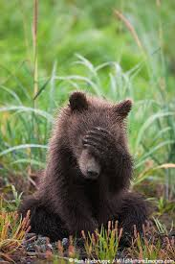
        - All AC – please update spreadsheet to reflect all the amazing things the AC has done, does, and will do.
        - Spreadsheet located in Drive
      - Statement of need/support,
      - Website info/stats,
      - Evaluations from presentations we have given:
        - Lara will create short evaluation form for participants/attendees to complete after AC presentations. Completion Date: 6/16/16
  - Movement Based Instruction – Train the Trainers
    - Jolanda will contact Laurie
  - North Carolina Council of Administrators of Special Education (NC CASE)
    - Professional educational organization affiliated with the Council for Exceptional Children and the North Carolina Association of School Administrators.
    - Possible presentation opportunity for AC – Lara will contact Laurie/Teresa Owens to inquire.
  - APE Job Assessment (Teacher Eval)
    - Develop a more appropriate evaluation tool that provides evaluators with an understanding of what to look for when observing/evaluating APE Specialists.
    - Partner with other itinerant, special service instructors (HI, VI, home bound)
    - Lara will contact Laurie.

- Future Meeting Dates
  - LT – September 23rd
  - All AC – November 10th @ NCAAHPERD-SM Conference
  - LT – February 3rd
  - All AC – April 28th

Meeting adjourned 3:00 pm.

