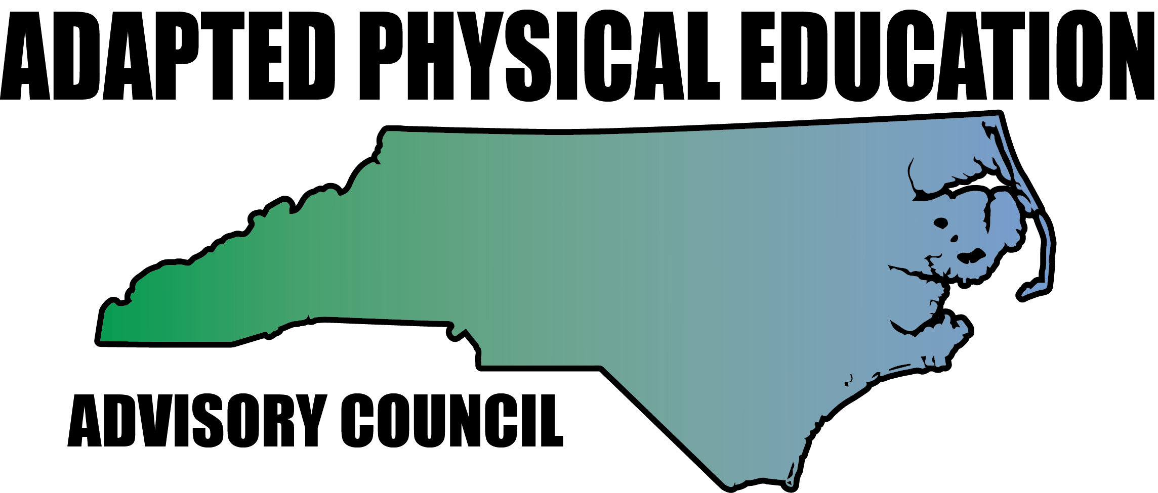

Meeting Minutes

Date: February 3rd, 2017
Location: Haynes Inman Educational Center, Jamestown, NC
Scheduled Start Time: 9:30
Attendees:
Council Members: Jolanda Hengstman, Barbara Meleney, Lara Brickhouse, Bob Beaudet, Teresa Hudson, Ann Hughes, Tim McMillan, Jennifer Parton, Ashlie Beavers, Amy Clark, Megan Davis, Kelly Givens
DPI: Dreama McCoy – Section Chief - Supporting Teaching & Related Services
Laurie Ray – Consultant for PT, Medicaid, and Liaison for APE
Guests: Brad Burke, APE, Rowan-Salisbury Schools

**Hyperlinks – Blue, underlined text is linked to additional info; press Ctrl+click link to access.

Jolanda called meeting to order.

- Greetings/Reminders/Quick Updates
  - Welcome Dreama McCoy (NCDPI Section Chief) and Brad Burk (APE – Rowan-Salisbury
Schools) to the meeting!
  - Complete mileage form and send to Melinda Tomlinson at DPI for reimbursement.
  - FYI – Jolanda and Amy have to leave meeting early.

- Calendar/Presentations:
  - All AC: send upcoming AC presentations to Laurie ONE month prior to event…Laurie will share with APE and EC Director listserve.
  - GREAT Activities
    - Jan/Feb – Jolanda
    - March/April – Barb
    - All AC: Article(s) needed for May/June (due April 1st)
    - All AC: Submit articles for future, encourage colleagues to submit.
    - Laurie will send “all call” to APE listserve
      - Jolanda – write up from email exchange attached, ready for Laurie to send?
  - Southern District Conference, Baton Rouge, January 9th – 12th, 2017
    - Lara attended, met former TOYs, assisted 2015 SD TOY, Anna Roberts, in presentations, touched base with Jade Ng (SQAIR), Sportime, US Games.
    - Conference was well attended, plenty of LA/Mardi Gras spirit, well organized, lots of networking opportunities.
    - 6 APE/APA related presentations – Inclusion, AU, T&F for Para-Athletes, Modifying Equipment for Success, Developing Rec. Programs, Benefits and Opportunities in Adaptive Sports
    - 2018 Southern District and National Convention in Nashville, TN
      - Council to explore presentation opportunities
  - APE Inservice, Carteret Co – Ann and Barb
    - Info flyer tweeted 2/15/17
    - Expenses covered – hotel, travel, and donation to NC-APE-AC
  - SHAPE National Conference, Boston, March 14th – 18th, 2017
    - Lara will attend – full schedule of TOY events and requirements
    - National TOY recipients announced at banquet March 17th
  - Physical Education Leadership Training (PELT), Black Mountain, March 31st – April 2nd, 2017
    - Online registration closes March 20th, 2017
  - National PE & School Sport Institute, Asheville, July 24th – 26th, 2017
    - Artie has offered accommodations, booth, and registration to AC at no cost
    - AC will present – Make it Take it, possibly session on AU…TBD
    - AC will contact the following groups/organizations to suggest collaboration and provision of APE “Point of View” within presentations:
This is a tentative list based on last year’s presenters…other groups/orgs we should reach out to?? Won’t know everyone that’s presenting until program is released.
      - 2016 National TOYs – Lara
      - US Games/OPEN – Lara
      - Sportime/SPARK
      - Flaghouse
      - Bridge II Sports
      - SQAIR – Ann
      - ExerciseBuddy – Lara
    - Can AC have MORE of a presence?
      - Jim Rich Service Award?
        - Award given by AC for support of all things APE…in Jim’s name, of course!
  - DPI Summer Institute, Greensboro, July 24th – 28th, 2017
    - Laurie submitted proposal for APE Goal Writing
  - Annual NCPEID Conference, Arlington, VA, July 27th – 29th, 2017
    - Bob and Lara discussed attending…final decision TBD
  - NCAAHPERD-SM Convention, Winston-Salem, November 2nd – 4th, 2017
    - NC-APE-AC will have info booth, presentations TBD
    - Deadline for nominations: July 1st, 2017
  - DPI EC Conference – APE Institute, November 15th – 17th, 2017
    - Call for proposals will be on March 15th
    - Deadline for proposals April 28th
  - Giveaways at Conferences
    - Amy will explore options for lapel pins, stickers, and magnets with AC logo
    - Lara needs to email Amy the image – STAT.

- Review of November 10th Meeting Minutes
  - NC-APE-AC PD Survey Results from APE Institute
    - LOTS of positives!!!
    - Highlights
      - Voluntary participation = 96.08%, Mandatory = 3.92%
      - Percentage that would attend additional sessions/presentations from NC-APE-AC = 92.16%
      - Three words to describe session:
        - “Fun, informative, realistic”
        - “Amazing, applicable, practical”
        - “Engaging, worth it!”
        - “Outside the box”
  - Current and Ongoing Projects
    - Structure and Leadership of AC – tabled
    - Equipment Bags for Presentations – Lara
    - Ideas for Equipment to US Games – Lara
    - Movement Based Instruction: Train the Trainers – Laurie
    - APE Job Assessment/Evaluation Tool – Laurie
      - Develop appropriate tool for itinerant teachers
      - CMS has started working on this.
      - When stakeholder group is formed, Laurie will reach out to AC for input and volunteers.
    - CAPE Certification – Jolanda
      - Jolanda spoke with Tim Davis from APENS
        - Updating current study guide, release of new edition has not been determined.
        - Tim offers email-based study assistance free of charge. Additional opportunities for study sessions/workgroups warranted.
        - Laurie will send out inquiry to listserve – want full or half day training?
        - Jolanda will contact Tim Davis to follow-up.
        - Lara will share contact info for NC A&T and ECU professors requesting assistance with Jolanda.
    - Workgroups
      - Communication Committee – Lara, Tim, Megan, Ashlie, Kelly
        - Lara will email committee
      - APE Manual – Barbara, Lara, Jolanda, Amy
      - EC Director Starter Kit – Barbara, Tim, Ann
      - University Communication/Assistance – Bob, Kaky, Vicki, Barbara
      - Grants – Jolanda, Kaky

- DPI Updates – Laurie and Dreama McCoy
  - New/redesigned IEP forms – intended roll out Fall 2017
  - DPI version of APE Powerpoint in final stages – awaiting approval from Bill Elvey
    - Will be posted on DPI APE webpage!
  - Ongoing debate – to re-eval, or not to re-eval…that is the question.
    - Decisions should be based on…
      - Mandatory testing/assessment?
      - Review of current data?
    - CMS has created simple document – see handout given at meeting
  - APE Brochure needs updating
    - Workgroup established – Laurie, Barb, Lara
  - Certified Adapted Physical Educator (CAPE) Endorsement
    - Laurie continues to advocate for CAPE recognition
    - NC State Board of Ed does not want to exceed federal requirements
  - DPI Guidance Documents
    - In process of being updated (last update 2008)
    - Will be re-posted to webpage when complete
  - APE Lending Library
    - GREAT resource, lots of good reads
    - Increase in traffic
    - SHOUT OUT to Laurie for maintaining this!
    - Lara will add link to library on NC-APE.com AND Tweet about it!
  - Regional EC Director meeting – May 2017
    - Dreama will advocate for AC to be added to the agenda.
  - Laurie has been invited to New Director’s Institute – lots of APE love to be shared.
  - Laurie has been working with Carol Ann Hudgens to include APE in DPI’s progress monitoring/compliance process.
    - Don’t panic!...unless you’re out of compliance ;)-
  - APE Consultant Position APPROVED!
    - Part-time position
    - AC will assist in identifying potential candidates
      - Current APE Specialists
        - Contract with school district
      - NC-APE-AC retirees
        - Send recommendations to Jolanda
    - AC will continue to provide proof/data indicating need
      - Ongoing updates to Activity Report
2017 Activity Report located in NC-APE-AC Drive Folder. Access via Google Drive, link sent in email, and/or this super cool hyperlink
      - Meeting Minutes
      - Webpage stats
    - A MILLION THANK YOUS to Dreama and Laurie!!!

- Website Report
  - Page Views per Week = 604 (as of Feb 28th)
  - Unique (first time) Visitors per Week = 238
  - Most recent updates have been made, more to come!
  - Lara will email Communication Committee for assistance, guidance, hand holding, and hugs.
  - All AC: please continue to send photos, videos, useful resources, etc to Lara to post.

- Sharing of Regional News/Updates
  - Region 1 – Lara:
    - APE Workshop @ ECU Feb. 27th – Coordinated by Dr. An, ECU APE Department
      - Bridge II Sports presenting various adapted sports/activities
      - Lara presenting on NC-APE-AC – will provide AC updates, ongoing/accomplished projects, upcoming presentations, show website, answer questions, etc.
  - Region 2 – Ann and Megan
    - Ann has been contacted by surrounding counties requesting assistance
    - Megan invited Charla Krahnke to present to Craven Co. PE teachers
  - Region 3 – Barbara
    - Extending support to county within Region 3 experiencing difficulties with mandates and expectations from county admin.
  - Region 4 – Kaky
    - Kaky was unable to attend the meeting
  - Region 5 – Tim, Vicki, Ashley
    - Five high schools within Guilford Co. Schools are participating in Special Olympics Unified Champion program (formerly known as Project Unify)
    - Vicki and Ashley were unable to attend meeting
  - Region 6 – Jolanda, Amy, Kelly
    - CMS is making moves!
      - APE Facebook page – lots of uplifting photos and videos!
      - Autism Newsletter – great resource. Newsletters are posted on webpage.
    - Gaston Co. continues to promote and establish Unified Champion schools.
  - Region 7 – Vacant
    - AC will continue to explore possible replacement.
  - Region 8 – Teresa and Jennifer
    - University student working with Teresa to complete practicum hours
    - Jennifer pushing to present to Region 8 EC Directors – keep on keepin’ on!
    - Clay Co. EC Director contacted Laurie with APE related questions.

- Future Meeting Dates
  - April 28th, 2017

Meeting adjourned 3:00pm

