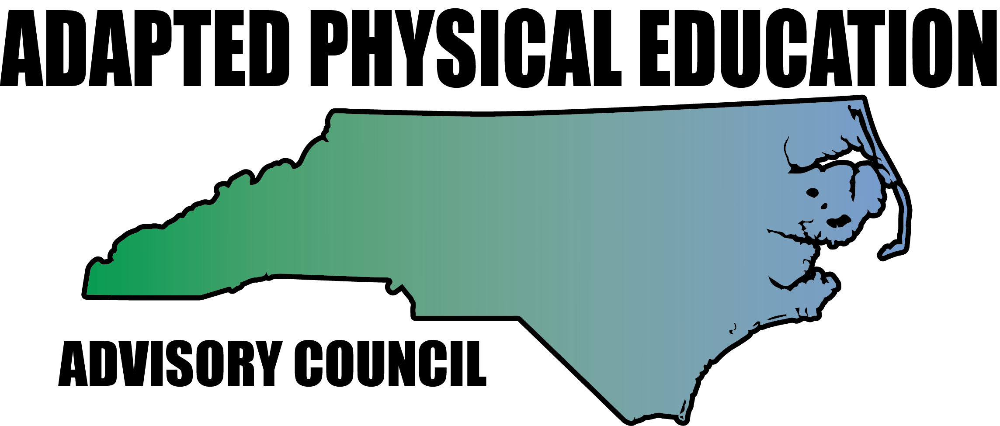

Meeting Minutes

Date: February 2, 2018
Location: Haynes Inman Educational Center, Jamestown, NC
Scheduled Start Time: 9:30
Attendees:
Council Members: Jolanda Hengstman, Barbara Meleney, Lara Brickhouse, Bob Beaudet, Teresa Hudson, Ann Hughes, Tim McMillan, Jennifer Parton, Amy Clark, Megan Davis, Kaky McPeak, Ashlie Beavers, Kelly Givens and Vicki Simmons
DPI: Laurie Ray – Consultant for PT, Medicaid, and Liaison for APE

Barbara called meeting to order at 9:55 am.

Welcome/Housekeeping
- Haynes Inman parade celebrating a 70th birthday for one of the PT’s at 10 am.
- Thanks to everyone who brought treats for the meeting!
- Congrats to Vicki for her Teacher of Excellence award for Guilford County!
- Congrats to Teresa for receiving the APE-TOY for this year!
- Jennifer proposed a t-shirt design: see the pictures attached to this email. If you visit S & S Active wear you can see different types of shirts. $8 for short sleeve, $15 for Long and $18 for a baseball shirt.

Updates on 501c3/Joining NCAAHPERD: see attached handout
- We will be changing verbiage of positions in November and add the 3rd position: President, President Elect and Vice President as a 3 year term.
- We need to create by-laws and a constitution ASAP
- We can create our own awards (up to 6).
- There was a NCAAHPERD board retreat that Barb and Kaky went to and they have since emailed information.
- As far as events go, we can do what we want and charge what we want (we keep all of the money!) All APE workshops come through the council.
- Our bank acct is at BB&T, Teresa keeps the checkbook and she, Aimee Scott and Carmen Glenn are the only ones with access.
- The generic NCAAHPERD webpage will have a link to our council website.
- NCAAHPERD is doing an e-newsletter that we can contribute to: send submissions to: Aimee Scott.
- We discussed selling shirts at conferences

Overview of NC-APE recent & upcoming presentations: *need others to step up and present at conferences instead of the same folks always doing it*
- Megan stated she will present on severe and profound

- EC APE Institute: see attachment for stats that Barbara shared at meeting
- Overall feedback was very positive: participation, activities (make it take it), practical applications, demonstrations, engaging & fun!
- Suggestions: more space, more demonstrations, reserve a portion of the workshop for specific questions.
- Work with Amy McLemore to have technology set up & backed up-help to embed videos into PowerPoint.
- Lara will create a folder on the Drive for videos: people want to see adaptive equipment.
- Laurie had some suggestions:
  - Offer more sessions at the PE Institute with offerings for different levels of participants (APE teachers, Service Providers, PE teachers, students)
  - Laurie offered money through DPI for a workshop proposal: 21st century-handouts using email or an APP instead of print outs.
  - Christie Roth’s You Tube channel has lots of videos of activities for severe & profound.
  - She suggests putting in the total number for workshop to try and get a bigger space.
  - Laurie stated that she thinks we are trying to do way too much in one workshop-need to break it down.
- Lara’s adventures…
- She sent out an email with all of the wonderful apps and cool stuff!
- She reported trying to recruit in NY.
- Speed Stacks wants to meet this summer to come up with some innovative ideas.
- OPEN: universal design, Paralympic *see email Lara sent out on 2/1/18 and send her rough ideas*
- SHAPE Southern district:
- Barbara and Jolanda are presenting a 75 minute make it take it session. Thanks ladies!
- SPELT:
- Megan will do slack lines and balance.
- Lara is not sure she can present on OPEN as it is a conflict of interests with OPEN & Sportime.
- NPEI: July 24-25
- Lauren Lieberman is a keynote speaker (Camp Abilities)
- Inclusion Rating Scale (testing instrument)
- Including VI in PE
- Wants to include “Universal Design”

DPI Updates – Laurie (Contract APE position: update & submit NC-APE-AC Activity log by February 28)
- Laurie to do an overview of APE with leadership.
- We can create on-line modules for Laurie to post on Canvas. Participants can get CEU’s through quizzes, homework and watching videos.
- She has been getting an increase in requests for IEP development/APE (PD available for request)
- Summer DPI Institutes can have contracts written for them so it can be strategic.
- Laurie can request funds (like mileage) for workshops.
- Laurie continues to put the APE consultant on her budget (even though it hasn’t been approved).
- She has completed the job description for the APE consultant, but nothing will happen until ECATS is rolled out.
- APE 101 PowerPoint hasn’t been posted publically yet due to no definitive guidelines: Who can teach APE?
- She has done a lot of research on this and what other states do.
- She feels there are compelling reasons to have certification.
- She feels it would be helpful to have a position statement.
- APE must be taught by a certified PE teacher.
- She is not recommending an APE point person in hopes that the consultant position will be approved.
- She is fighting for APE to be with curricular areas (Evaluations listed under curricular areas-not “other”)
- Laurie sent out ECATS info to the APE listserv: June 16-July 20 is the blackout period for ECATS & CCATS. July 2018 is the statewide implementation-depends how the pilot goes.
- See the ECATS website for information: http://www.ncpublicschools.org/ecats/
Lara’s National Travels and Governor’s Teacher Advisory Committee updates:
- Governor’s Position on what PE will look like in 2018-19:
- He supports PE-may be making a PSA re: your rights with info on who to contact in your area.
- Write a hand written letter to your legislator-Lara suggests that each school system give their teachers 10 minutes to write them.
- The Governor’s Council is looking for good things going on in each district-you can send to Lara.
Attrition: BIG DEAL with problem solving (teacher prep) 5,500 teachers left (3,000 beginning teachers) NC last year.

Kaky’s Data taking App:
- Kaky shared that she is working with two others to create an app for taking APE data.
- She will need others to pilot.
- The app will be for purchase.
- Closer to the end of the semester on a Saturday, she will meet with them to discuss how it works and piloting it.

Updates by Region:
  - Region 1 – Lara
- Camden Co/Elizabeth City asked for a presentation on severe AU.
  - Region 2 – Ann and Megan
- Had someone reach out about UNC-W aquatics workshop, but never got back in touch.
  - Region 3 – Barbara
- Barbara will be retiring at the end of the year-there will be two APE openings in Durham in July.
  - Region 4 – Kaky
- Gets calls from Scotland Co.

  - Region 5 – Tim, Vicki, Ashley
- 7 APE specialists in Guilford County

  - Region 6 – Jolanda, Amy, Kelly
      - Kelly and Jolanda put together a presentation for Gaston County, but the snow day has delayed it.
      - Mark Manross (PE Central) called regarding North Shelby HS (self-contained school) wanting a presentation on APE in August. This would be on behalf of PE Central.
- CMS and SO are offering a Unified Champion Schools presentation on a Saturday for 4 hours to talk about what it means to be a UCS school, offer demonstrations, and to recruit more UCS schools. This is for 1 Gen-Ed and 1 PE teacher from each school. UCS gives each school $100 for transportation and $250 for equipment and t-shirts.

  - AC will continue to explore possible replacement for Region 7
  - Region 8 – Teresa and Jennifer
- Buncombe County has been asked to do a 2 hour in-service for the district on: APE 101, having a sensory friendly gym, a yoga demonstration and resource sharing.
- District 8 wants a presentation for teachers, parents, etc... In April of this year.

University Update: Bob
- Bob was contacted by the department of labor as an expert in the field of APE!
- They want input to go through surveys in order to update job information on APE.
- NCPEID directed the DOL to Bob-so THANKS to YOU!

Updates in NC Politics/News: Vicki
- Schools had to apply to do the double entries for the ECATS pilot.
- Bill Hussey said the forms will be available for teachers to look at next month (March).
- POLITICS: Make friends, then ask for help-kudos to you Vicki for being an amazing advocate! Laurie suggested Vicki instruct others on how to advocate
- The DPI Summer Institute is always the last week in July at UNC-G.
- Davidson Co. will have an opening as Stephanie Shoaf is leaving.
- CAPE at NC-ATT…anyone hear anything? We think everyone is waiting until the new rollout.
- Haynes-Innman does an awesome Indoor/Outdoor adventure Day in cooperation with Parks & Recreation.
- Vicki shared that her principal walked 28.3 miles to raise money for Make a Wish and the school sponsored him through a “Walk & Wheel” event to raise funds-COOL!
- ECATS training happened on 2/19 and the pilot was implemented on 2/23 (TODAY!)

Financial Report: Teresa
- $ 320.25 in the account. Hoping that this time next year we will have a lot more! A discussion was had (at the meeting and via emails) about ordering new business cards. I believe the consensus was to order just enough to get though and wait to see if NCAAHPERD changes names to SHAPE NC.

Website Updates: Megan
*Reminder to update the Activity Log on the webpage when you talk to folks who reach out with the time spent.
- If you have anything for the webpage-please send it to Megan or Kelly

Last minute information:
- DPI is now monitoring APE and they are looking at verification of service delivered, lesson plan, attendance & what you did (worked on: like objective #2)
- Lack of connection between goals & program (goals continuing and not being updated)
- Laurie suggested we send a sample template to DPI progress monitors and HI, VI to see if it will work for them.
- *Kelly will send the form for progress monitoring.

Upcoming Great Activities submissions:
- Ashlie will be featured next!
- April 1: Kelly

Work Goal: tabled until next meeting
- Position Statement with licensure recommendations

Future Meeting Dates:
- April 27 is the final meeting for the year.
- Dues due? Not sure….

Meeting adjourned 2:24pm
Respectfully submitted by: Amy Clark

