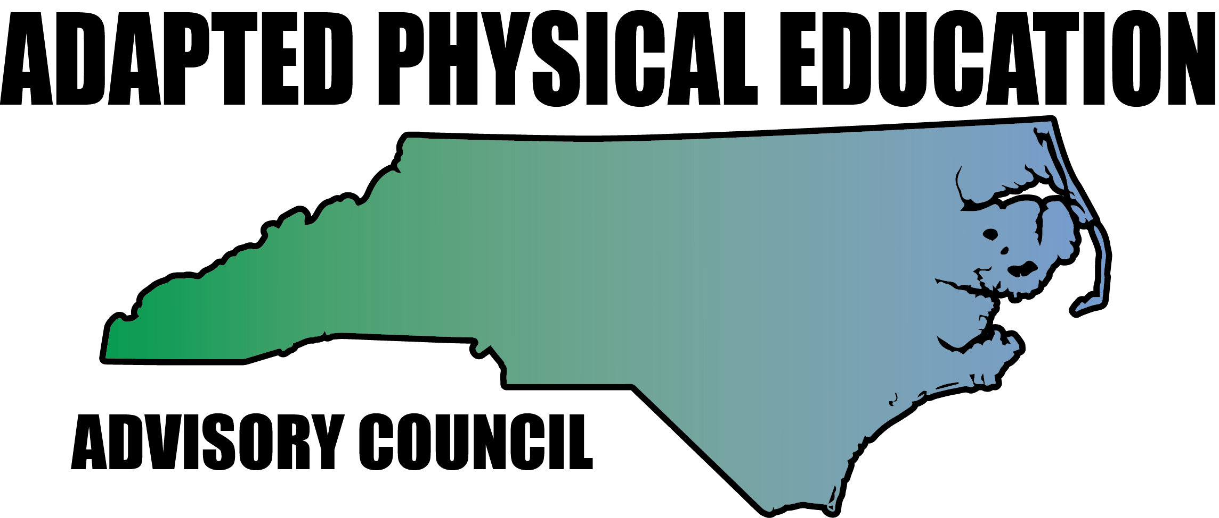

Meeting Minutes

Date: November 2, 2017
Location: Benton Convention Center, Winston Salem, NC (in conjunction with the NCAAHPERD conference)
Scheduled Start Time: 10:00 am
Attendees:
Council Leadership: Jolanda Hengstman (had to leave early for grant luncheon), Barbara Meleney, Lara Brickhouse, Teresa Hudson, Ann Hughes, Tim McMillan, Jennifer Parton, Amy Clark, Kaky McPeak and Ashley Beavers.
DPI: Burt Jenkins-DPI liaison for HPE
Council Members: Amy Stadiem-Wilson Co. and Brad Burke-Rowan Co * invited to join at 10:30 am*

Barbara called meeting to order at 10:04 am

Update and vote on 501c3
- Barb called in to Triangle Advising to get a free 20 minute consultation. They advised that we go under NCAAHPERD as they have just renewed their non-profit status.
- Barb had a conversation with Amy Scott (president of NCAAHPERD) and she is very open to us joining under the umbrella of NCAAHPERD. She asked Barb to write a letter for her to share with the board (which she did and it was shared on Wed. 11/1/17) and they voted to approve us coming on board.
- Info:
- We can go under as our own APE Council
- We can approve awards, add additional awards and collect the nominations
- Within 3 years we will need to be up to 50 members (which should not be a problem since you currently get to choose 2 sub categories when you join NCAAHPERD)
- We will have to have by-laws
- This will NOT affect our relationship with DPI-(we will still submit a budget for mileage reimbursement through them)
- WE would not have our own checking account-monies will filter through NCAAHPERD
- We can link to the NCAAHPERD website
- We can keep our name as is : Council
- We will fall under NCAAHPERD’s liability insurance
- Barb will sit down with NCAAHPERD to get more information on the pros and cons of this relationship. Tentative to no red flags from Barb’s meeting with Amy Scott, it was voted on by the council members present that we should move forward with this arrangement.

Celebrations/Announcements
- Teresa Hudson is our new APE Teacher of the Year!!! WAY TO GO!!!
- On Nov. 16th Vicki will be awarded the Educator of Excellence award at the CEC conference-YAY!! Jolanda is attending as her guest.
- Bob did not receive the University award
- Doug Smith (Charlotte) did not receive the Elementary Teacher of the Year
- NCAAHPERD is aware that they need to revamp how the awards recipients are awarded.
- Lara commented that Southern District only got one APE nomination, but that they still went through the rubric to ensure it was an appropriate candidate.
- Burt mentioned he is working to push the nomination timeline out to 6 months to begin thinking about nominees.
- Jolanda (CMS) was awarded a $1250 grant from NCAAHPERD for the trikes in CMS to be fixed and for helmets to be purchased.
- Kelly Givens son Charlie is finished with his treatments for cancer. Barbara alerted the council that she never received her card and $80 gift card.
- We have three new members joining the council membership: Amy Stadiem from Wilson County, Stephanie Shoaf from Davidson County and Brad Burke from Rowan County.

DPI Updates – Laurie: absent and did not get back with Barbara
Laurie strongly suggests to the council: make a position statement with licensure recommendations, what is acceptable, what is not for APE hires. This needs to be submitted to Dreama and Bill Hussey.

Lara’s National Travels Update:

- Minnesota Developmental APE Educators Conference was GREAT!
- Oregon Conference was another great one-learned about Pumper Cars-so cool! Check them out here:
https://youtu.be/AzD7811q0aA and the website: http://www.pumpercar.com/adapted-physical-education/
- Lara is doing another Pod-cast with Scott Mcnamera: “What’s new in APE?” You can find it on any Pod-cast APP.
- Lara is going to present in VA and NY and then wrap it up in Nashville in March.
- Lara informed the council that Sportime has been donating all of the equipment to a school in need in the areas they travel. COOL BEANS!

Upcoming NC-APE Presentations

- CAPE session with Tim Davis-was on Sept. 23rd hosted by Jolanda/CMS. CMS custodial services picked up the tab for the Saturday use of the room. We used Google Hangout and it was suggested that maybe we look at holding in-services using this method. Tim was an engaging speaker and it was well received. * Hits on the website went up about 500 after this was posted!
- CEC: APE Institute: Barbara and Jolanda presenting on November 15th from 9-4pm. As of the meeting date, there were already 91 registered! NEEDS: glue guns, tube socks, contact paper, newspapers and egg cartons for the “Make it Take it” portion. If you would like to help-Laurie can get passes for Council member, but you will not get a nametag or be eligible for CEU’s.
- SHAPE Nashville: March 21-24. Barbara, Lara and Jolanda put in to present-still haven’t heard anything.
- Council REQUESTS: Laurie is getting req’s for APE technical help- she suggested that the council will need to set up boundaries on what we can reasonably do.
- Innovative approaches (April/May) in Allegheny, Ashe and Watauga Counties looking at inclusive recreation and APE-pairing with APP State Recreation services. Teresa, Jennifer and Bob
- Davidson County wants an AU in-service. Vicki and Tim?
- Scotland County???
- Elizabeth City wants an APE 101 session
- Wayne Co. MS/HS PE director

Updates by Region
- Region 1 – Lara
- Nothing to report

- Region 2 – Ann and Megan
- Outreach to Brunswick Co.
- Region 3 – Barbara
- Barbara will be retiring at the end of the year-there will be two APE openings in Durham!
- Region 4 – Kaky
- Region 5 – Tim, Vicki, Ashley
- Ashley were unable to attend meeting
- Lara gave Tim the name of someone wanting HS curriculum.
- Region 6 – Jolanda, Amy, Kelly
- Kelly was unable to attend the meeting
- Iredell has reached out wanting an in-service, but it was over the summer when no one was available.
- AC will continue to explore possible replacement for Region 7
- Region 8 – Teresa and Jennifer
- Nothing to report

Updates in NC Politics/News: Vicki-absent

University Update: Bob-absent

Financial Report: Teresa
- Currently our pot holds $320.25

Website Updates: Megan-absent

Upcoming Great Activities submissions:
- Dec 1st: Amy, Feb. 1st: Lara & April 1st: Kelly

High school/Transition IEP’s:
- Kaky offered to look into this further

Job security:
- Burt talked a bit about the reduced class size in K-3
- Every LEA will have to look at it differently
- Need teachers, parents, students to lobby HARD against this legislation.
- Cuts are coming across the board
- Burt suggested we go to: http://www.ncleg.net/ to find our local area representative.

Barb is going to work on the position statement for licensure and the medically fragile: please let her know if you would like to help out. *Kaky offered to help*

Charter School Requirements:
- Requirements should not be any different since its legislated.
- Charters are taking over low performing schools.
- Barb stated that her students with APE who transferred to Charters had it taken off of the IEP completely.
- Amy stated that she had a student come to her with 4 pages of goals and she is currently seeing this student 1:1 three times/week for 30 minutes.

*Reminder to update the Activity Log on the webpage when you talk to folks who reach out with the time spent.

Meeting adjourned 11:40 am
Respectfully submitted by: Amy Clark

