www.nc-ape.com
Ashlie Beavers, MS
Adapted Physical Education Specialist, Greensboro NC
beavera@gcsnc.com

Tallest Towers
(Activity modified from projectfitamerica.org)
This is a great activity that is easily modified to include students with various disabilities into a general PE class.

Materials:
As many fitness/building cups that you have (such as PFA, plastic, or paper cups)
Hula hoops (8-12 depending on size of class)
Large dice (2 for each hula-hoop)

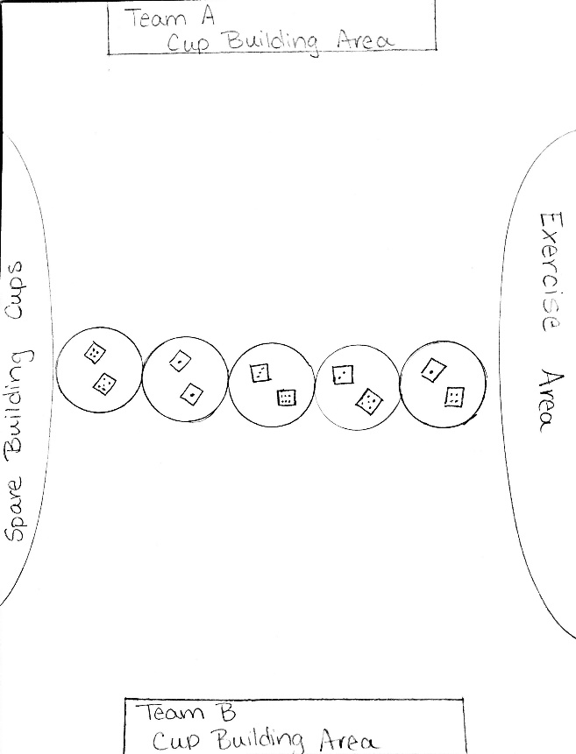

Set Up:
Divide the class into two equal groups on opposite sides of gym or play area.
Across the middle of the gym, place hula-hoops on the floor as a divider between the two sides. In each hoop, place 2 large dice.
Place a large group of building cups in an easily accessible area for all students on both teams.
Designate a cup building area on each team's side as well as an exercise area.

Game:
- This game focuses on fitness skills, teamwork, cooperation, IEP goals, endurance, and math skills.
- One person from each team faces off at each hula-hoop.
- Each student will roll one or both dice to determine the winner of that round. (Depending on the grade level the winner of the dice roll can be determined by greater than/less than, sum/difference, or product).
- The winning partner should retrieve 2 building cups and take them back to their team cup building area.
- The second partner will perform a teacher specified exercise in a designated area. This is an excellent opportunity to give students a choice as well as an opportunity for students with an IEP (individualized education plan) to work on their specific goals.
- Once each partner is finished with their task they will then hustle back to an open hoop and a new partner to begin another round.
- Rounds will run continuously until the teacher stops game play to determine which team has the "tallest tower".

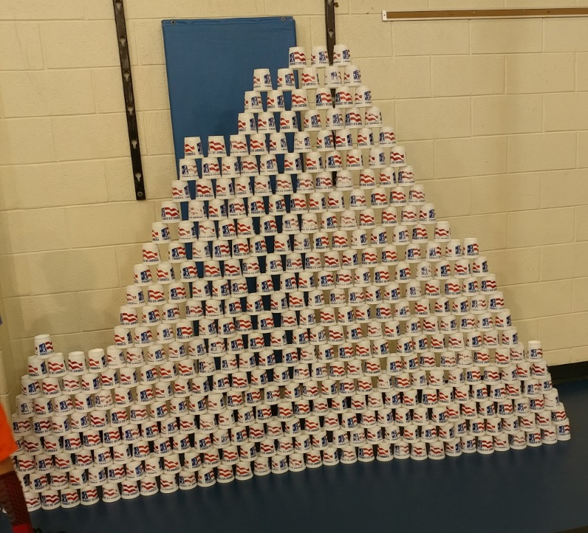
Modifications:
Modify math skills to meet the learning needs of the students.
Students that use wheelchairs can build their cups on an elevated surface such as a table or desk.
Shorten or lengthen distances to building cups and building area depending on student need.
Encourage peer partners for students that may need additional help.
Modify fitness exercises for students with disabilities (fewer repetitions, modified push-ups, jumping jacks using only arms etc.)
Use pedometers to encourage more running and endurance as well as incorporate more math.

