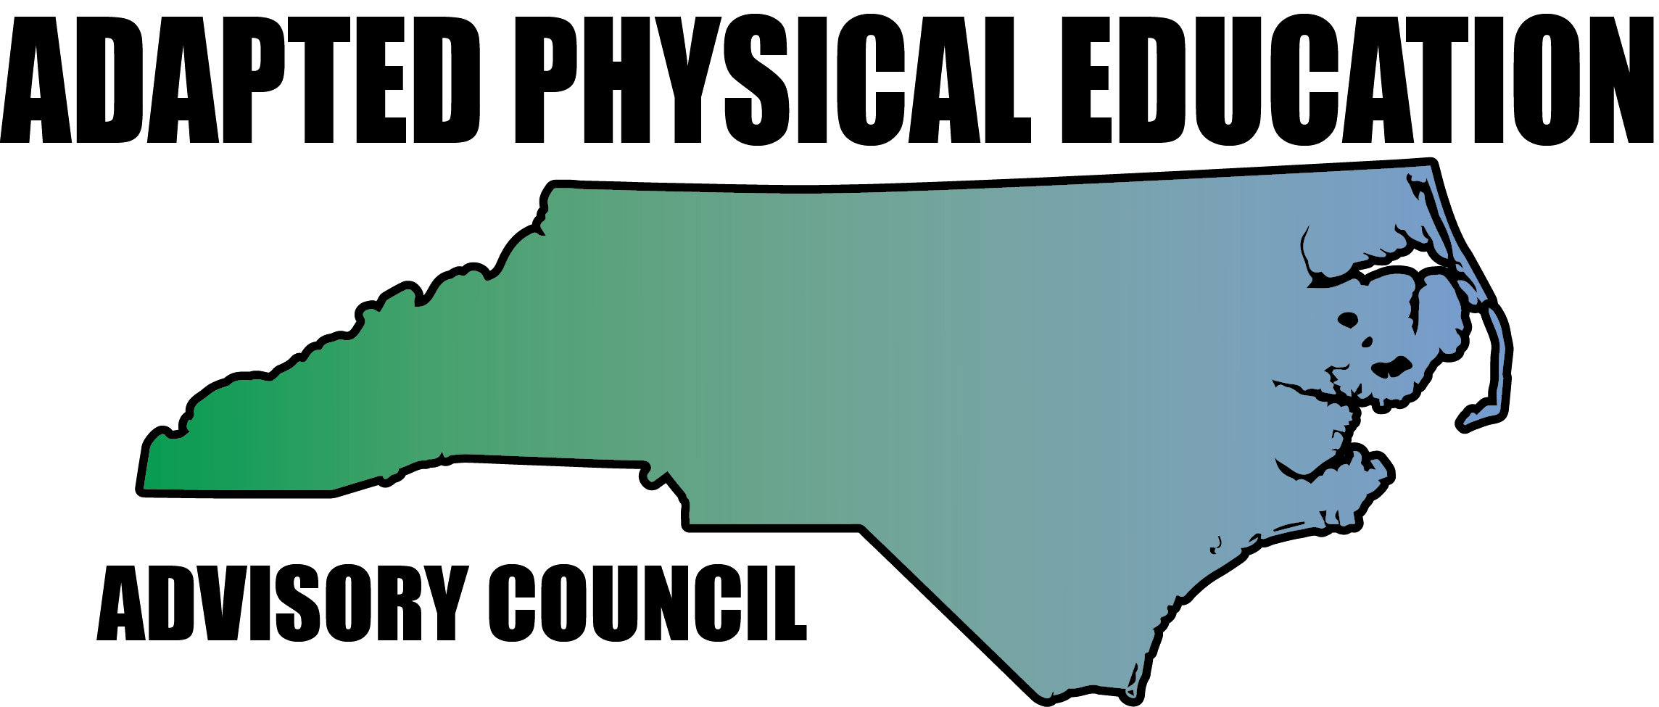

www.NC-APE.com NCAPEAC@gmail.com

Adapted PE Guidelines and Goal Writing

Definition: NC 1500-2.1 Adapted physical education (from The Policies Governing Services for Children with Disabilities).
(a) Children with disabilities shall have equal access to the provision of physical education. Physical education includes the development of:
(1) Physical and motor fitness;
(2) Fundamental motor skills and patterns; and
(3) Skills in individual and group games, sports, and activities (including intramural and life-time sports).

(b) If a child with a disability cannot participate in the regular physical education program, individualized instruction in physical education designed to meet the unique needs of the child shall be provided. Physical education may include:
(1) Modified physical education,
(2) Adapted/special physical education,
(3) Movement education, and
(4) Motor development.

(c) Modified physical education is appropriate for a child who can participate in the general physical education program with accommodations or modifications. These modifications can include changing rules, equipment, time limits, etc. It can also include supports such as a sign language interpreter.

(d) Adapted physical education (also called specially designed or special physical education) is instruction in physical education that is designed on an individual basis specifically to meet the needs of a child with a disability.

What is Adapted Physical Education (APE)?
Adapted PE is Special Education, NOT a related service.
Adapted PE is a program, not a placement.

How is the Need for APE Determined?
The IEP Team determines a student’s need for APE.
The IEP team should include an APE specialist, if available, and the general PE teacher.
To determine eligibility, an APE evaluation must take place in accordance with NC policy {NC 1500-2-11A}.
Goal (s) must be developed if eligibility for Adapted PE is determined.

Individual Educational Plan (DEC 4)
Present Level of Academic Achievement and Functional Performance is comprised of 5 parts.
- Data based student specific information related to current academic achievement and functional performance.
- Strengths of the student.
- Needs resulting from the disability.
- Effects of the disability on involvement and programs in the general education curriculum.
- A statement describing the student’s functional performance in the school environment.

For example: Based on assessment data and anecdotal logs of observations ___________ is able to _________________________________________________________________________________.
______________ Continues to have difficulty with ________________________________________. These skills impact his (her) ability to participate in the general education environment because __________________________________________________________. These skills also impact his/her ability to function in the total school environment. (Or if no impact you would write: These skills do not impact his/her ability to function in the total school environment.)

Annual Goal:
The annual goal consists of 4 parts.
- Any important givens/conditions as applicable (when, with what, where….).
- A skill domain area.
- An observable learner performance.
- Measurable criteria which specify the level at which the student’s performance will be acceptable. Must include a minimum of one measurement of progress as long as it sufficient to gather ALL of the data needed to report progress on each annual goal.

Example: Given (skill area) , (Student) will (observable performance) in measurable criteria .

Short Term Objectives:
Short term objectives are required only for students in Grades 3-10 who are assessed with NCEXTEND1.

Participations/Accommodations:
The IEP team determines if accommodations are needed if the student will be participating with general education peers – whether the student is receiving adapted PE or PE with accommodations.

Special Education location:
The IEP team determines the amount of service time for adapted PE (e.g., 1 x per week @ 45 minutes per session) and where the service will be provided (e.g., Special Education or Regular Education).

North Carolina Adapted Physical Education Advisory Council (NC-APE-AC)
www.NC-APE.com
NCAPEAC@gmail.com

