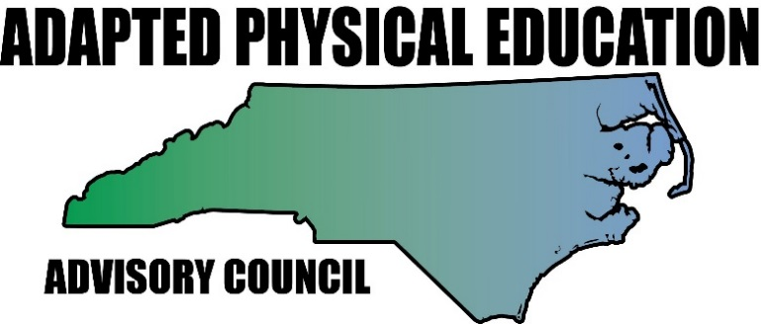 Council meeting
February 3, 2017
Haynes-Inman Center
Call to Order and Welcome
Previous members now leadership
Reminders: mileage reimbursement and working lunch

Calendar/Presentations:
January 9 – 12 2017: Southern District conference in Baton Rouge
March 14 – 18 2017 SHAPE in Boston
Great Activities article due dates: December 1st for Jan-Feb issue. Jolanda
February 1st for March-April issue. Barbara
April 1st for May-June issue. ??
February 20 2017 APE Institute for Carteret Co. Schools from 8:30-3:30.
April 28, 2017 NC-APE-AC meeting at Haynes Inman, Jamestown NC
July 1 2017: deadline for nominations for NCAAHPERD-SM
NPEI dates: July 24-26 2017 (Monday – Wednesday) in Ashville NC.
NCAAPERD-SM: November 1-4 2017 (Wednesday – Saturday) in Winston Salem NC
DPI Conference on EC – not listed (usually early November)

Review meeting minutes November 10, 2016
Evaluations from DPI-EC conference on the APE-Institute?
Action Items: PD-flyer for charter schools (Tim)
Presentations: teaming up with other organizations/presenters Lara to follow up with USGames presenter network, TOYs, SPARK
Bridge II Sports in need of schools to present at

Treasurer report: Teresa

Website report: Lara
Great group photo
Host responsibilities form online?

Google docs:
Activity report
Equipment ideas

News, happenings and questions since our last meeting (report by region)
1: Lara
2: Ann, Megan
3: Barbara
4: Kaky
5: Tim, Vicky, Ashley
6: Jolanda, Amy, Kelly
7: vacant
8: Teresa, Jennifer
University: Bob

DPI updates:
Lending library
APE consultant
CAPE acknowledgement

Current and ongoing projects/work groups:
Structure of Leadership Council – how to move forward and create interest to join.
Equipment bags/presentation bags – Lara
Ideas for new/adapted equipment – Lara
Movement Based Instruction in the classroom – Laurie
APE job assessment – developing a more appropriate evaluation tool
CAPE certification – options/opportunities
Work groups: Communications – Lara, Tim, Megan, Kelly, Ashlie
Manual – Barbara, Lara, Jolanda, Amy (includes unifying forms)
EC director starter kit: Barbara, Tim, Ann
University – Bob, Kaky, Vicki, Barbara
Grants – Jolanda, Kaky

Work group time
Time to be used by sub-groups to work on projects and action items.

New action Items

